Collection: Is a group of individual objects represented as a single entity.

Collection: is used to store values. We can use arrays as well to store values, but array has some limitations.

Collection: It is an interface

Collection**s**: It is a class

We have many interfaces and classes in collection.

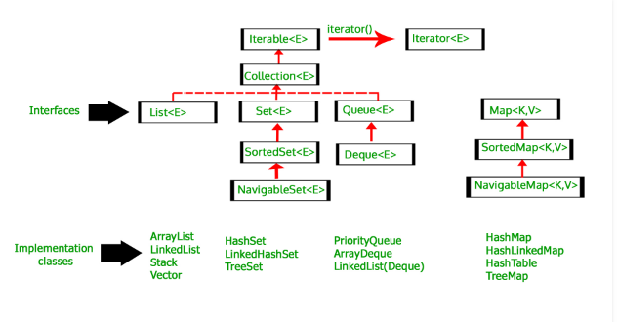

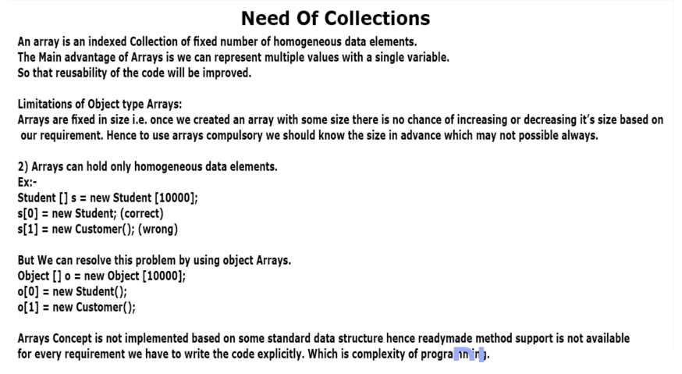Because of these limitations, we prefer to use collections. Advantages of collections :

1. It is growable in nature.

2. It can hold both, homogeneous and heterogeneous values.

3. Readymade methods are available for collections which we can use. It provides accuracy and it saves programmer’s time.

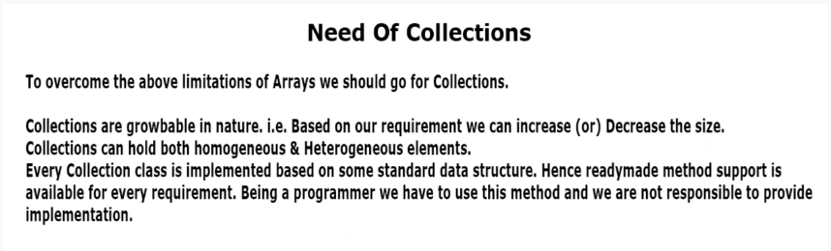If we use collection, and if we need more space, a bigger collection is created in memory and all exciting values are copied to new big collection Just to add a new element. Then, the older collection is eligible for garbage collection. It is time consuming to copy entire values just to add a new value.

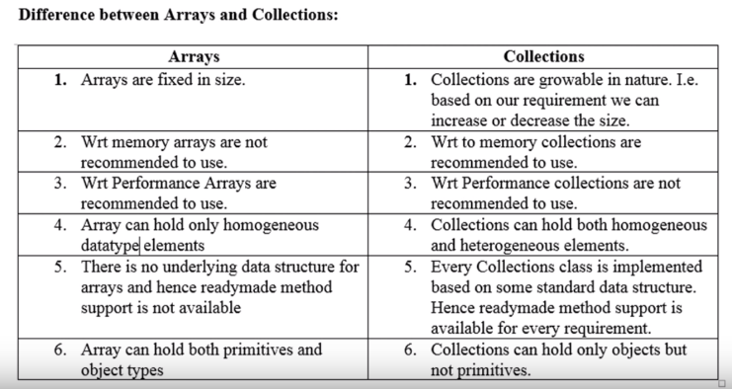Collection framework :

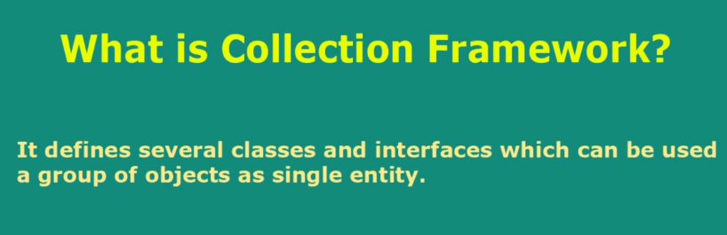Collection framework is made up of several classes and interfaces.

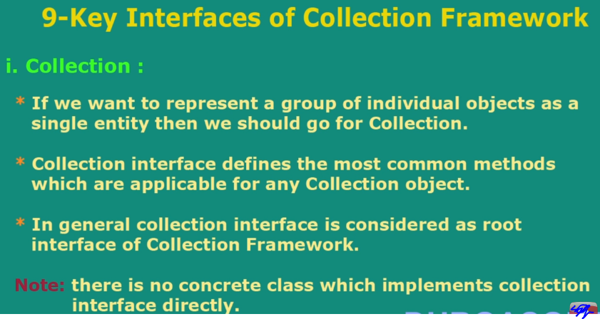Collection interface possess most common methods used for collection. For example, add, remove, contains, isempty.

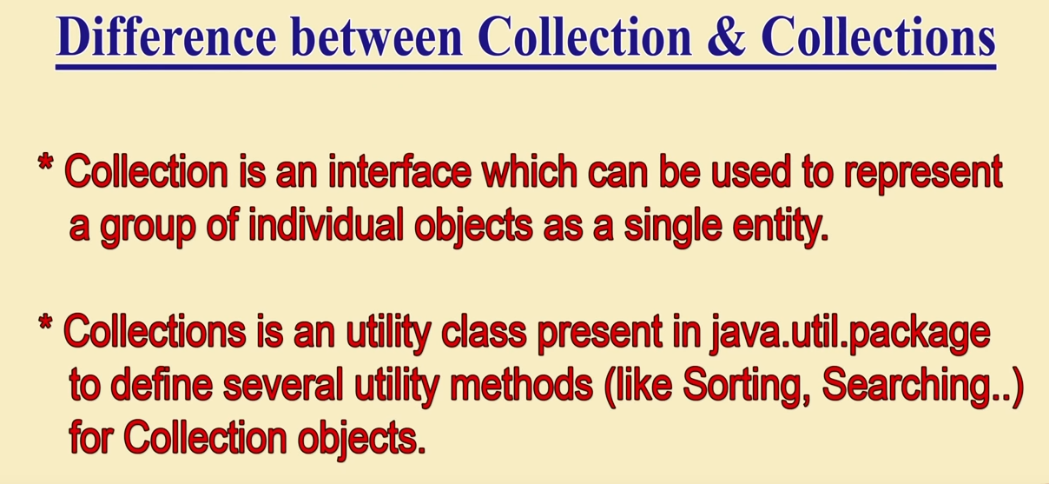

2. List

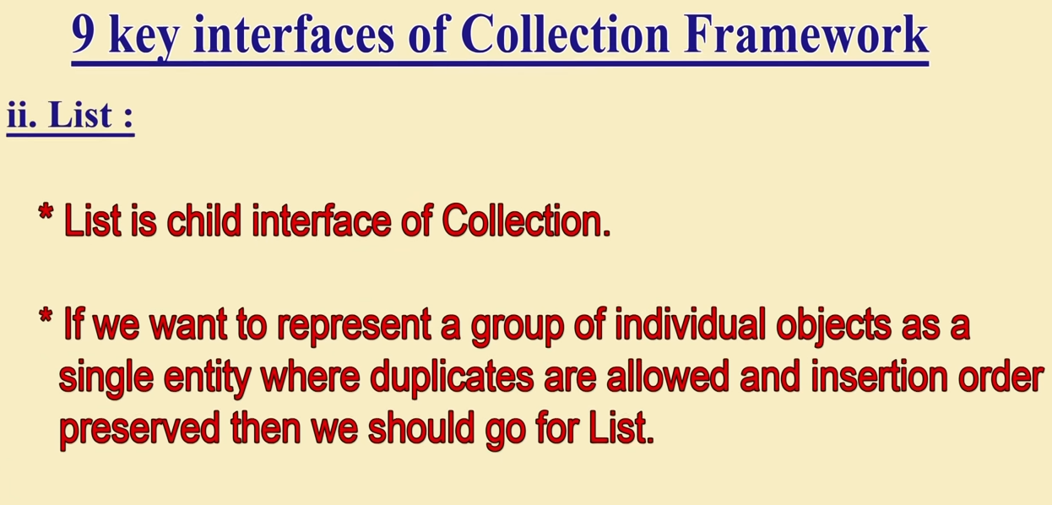

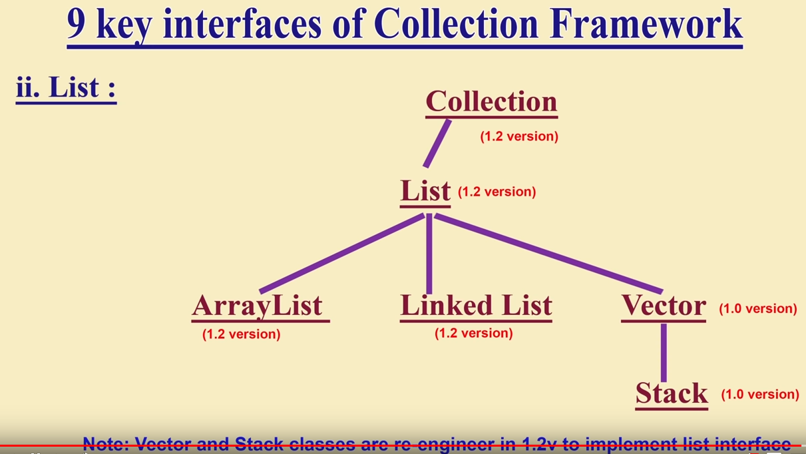

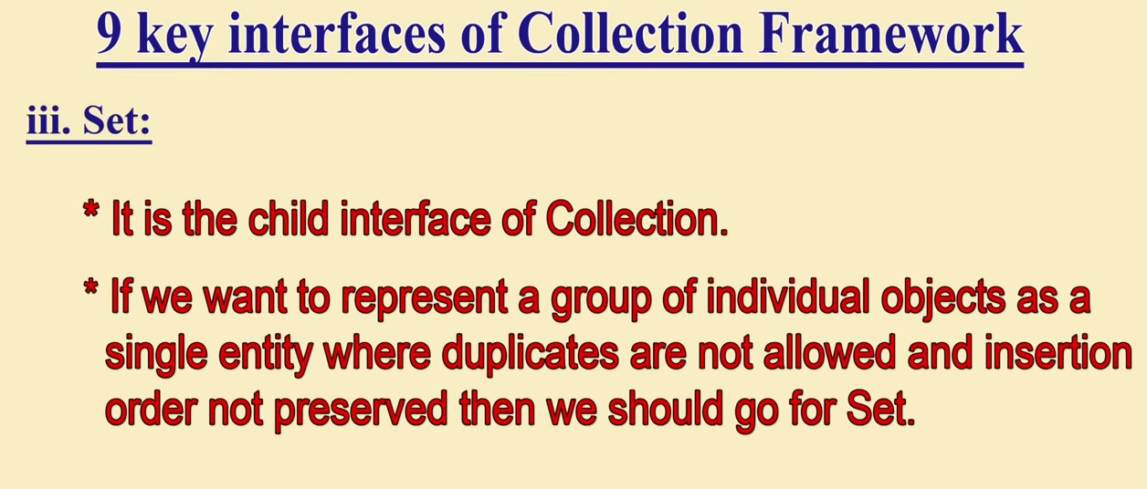

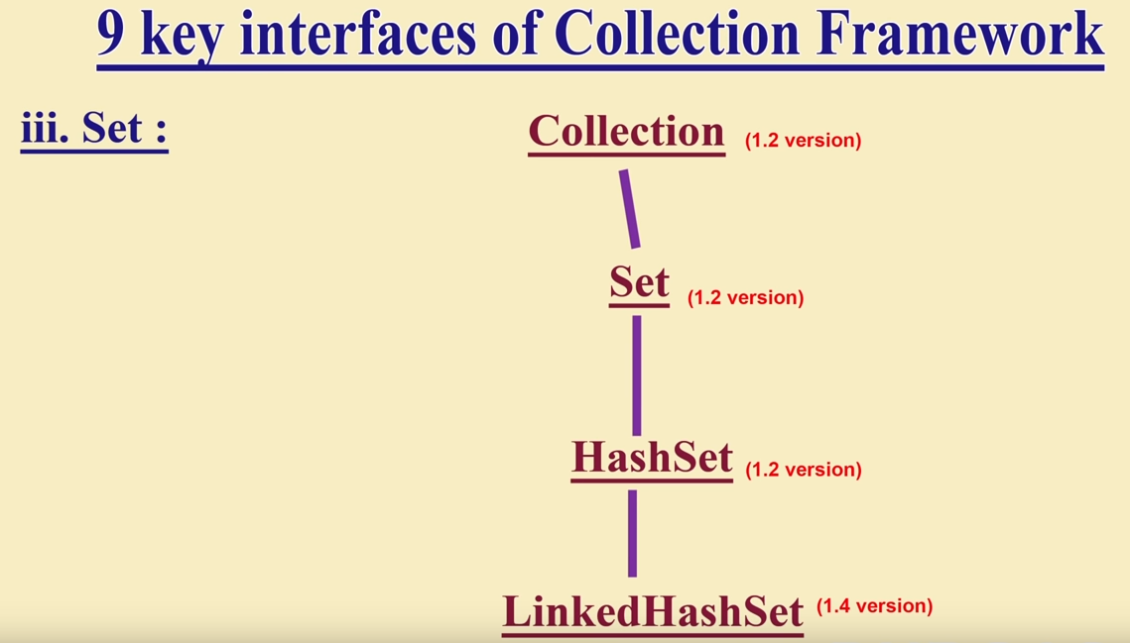

9 key interfaces of Collection framework - iii. Set

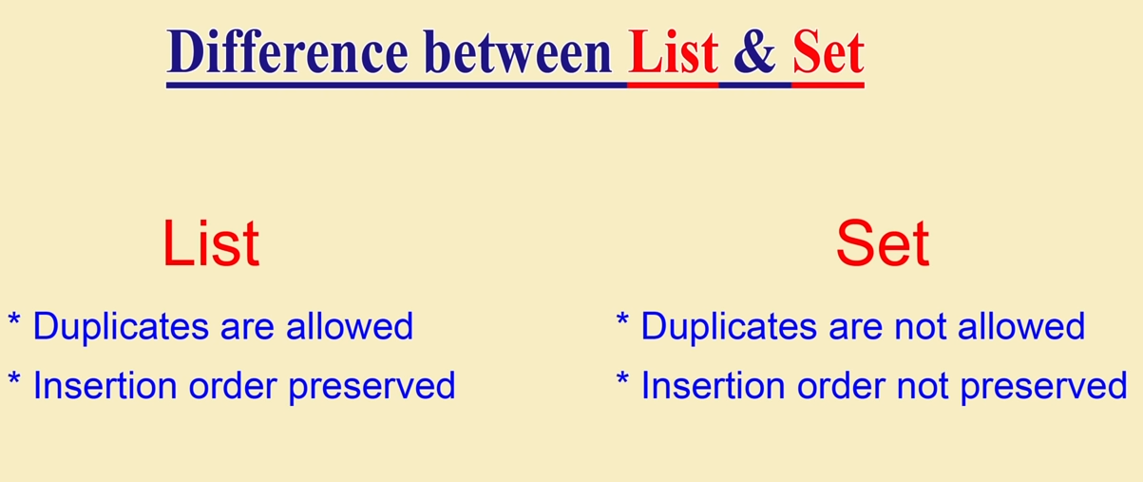

4. Sorted set :

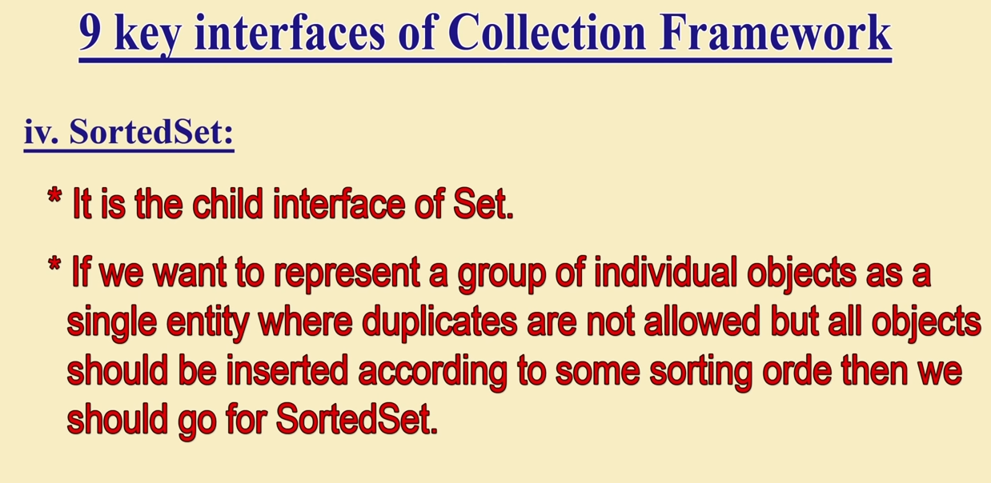

5. Navigable set :

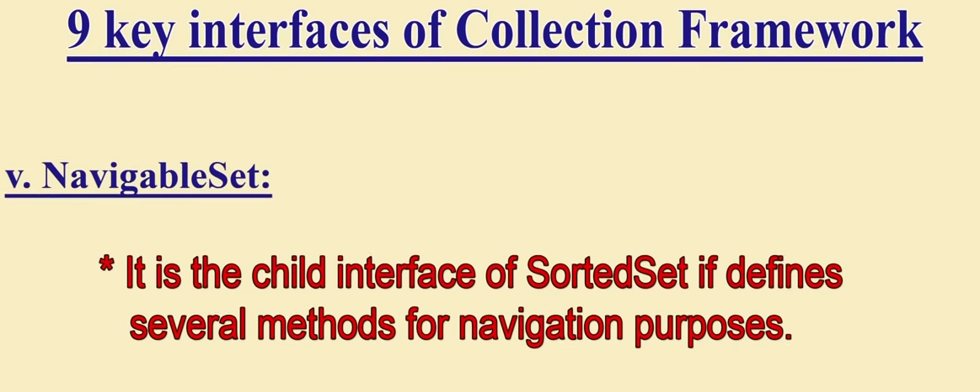

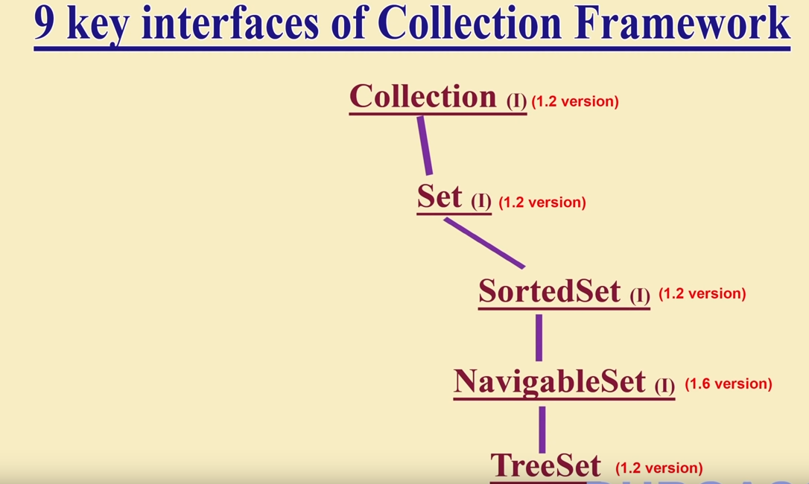

6. Queue :

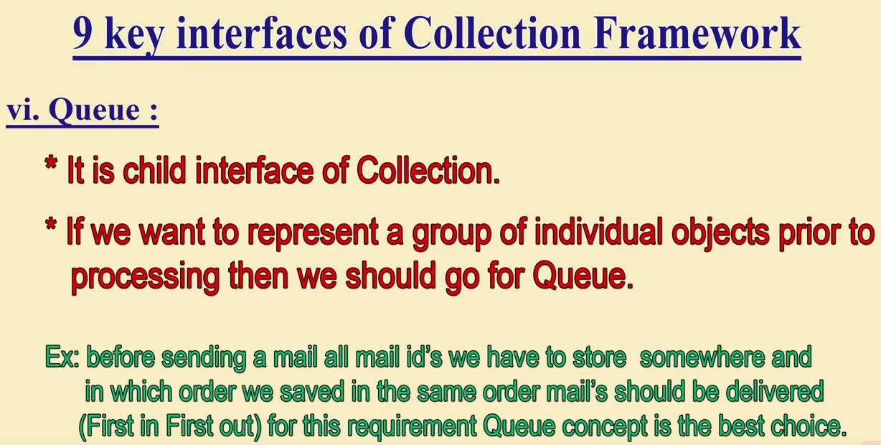

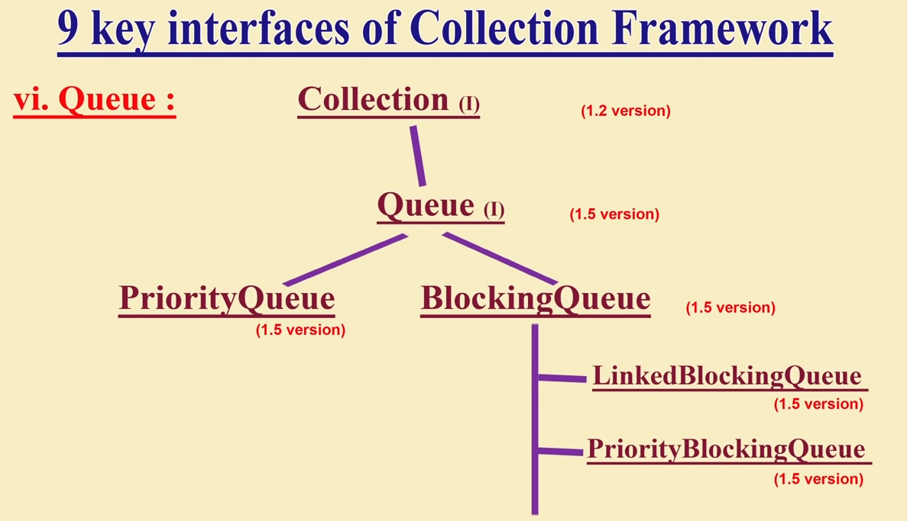

Blocking Queue is an **Interface.**

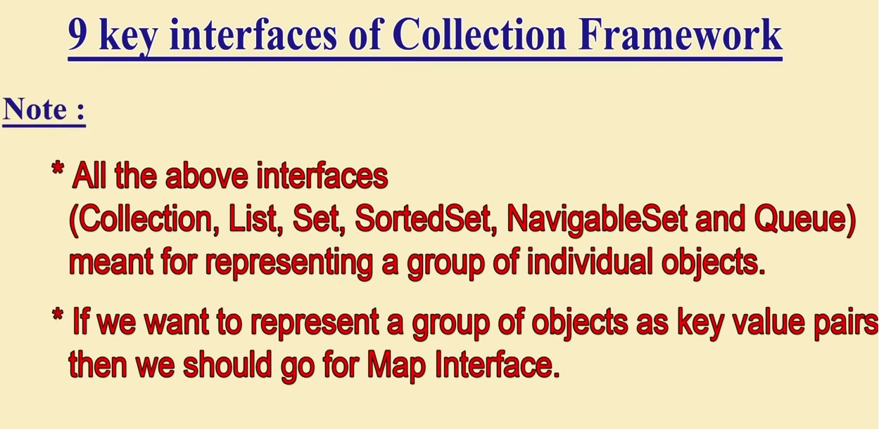

7. Map

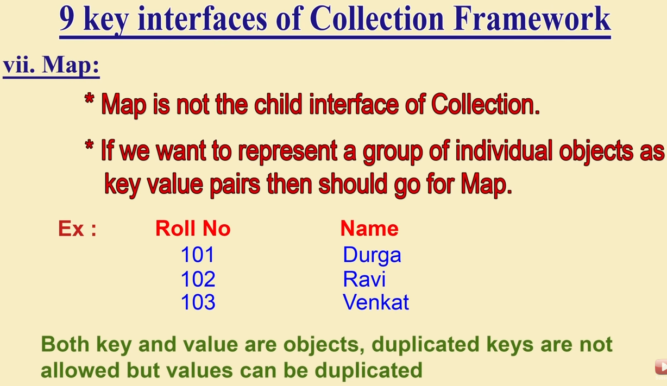

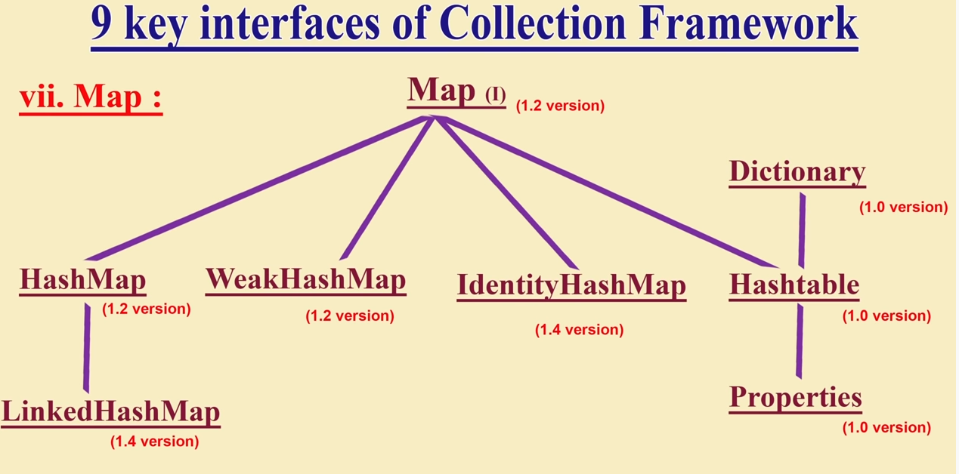

8. Sorted map :

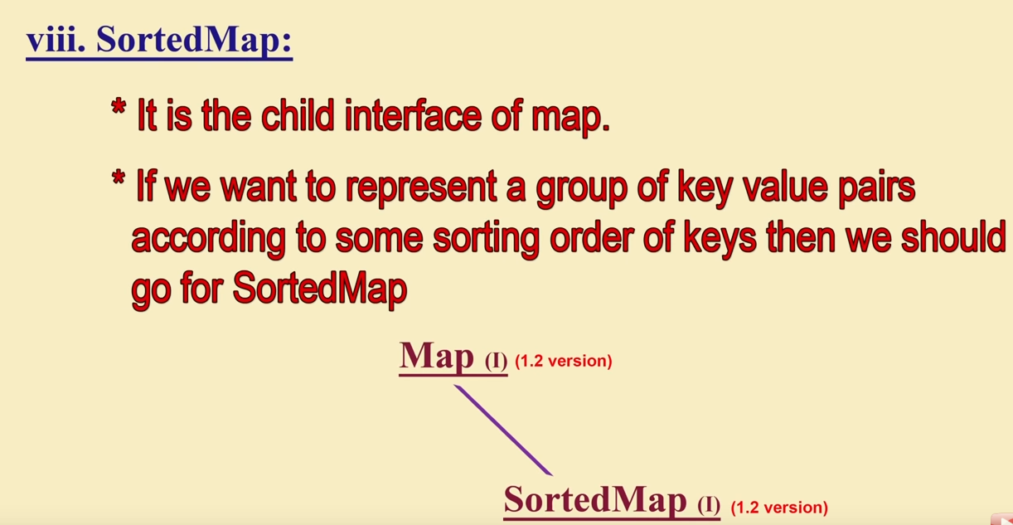

9. Navigable map :

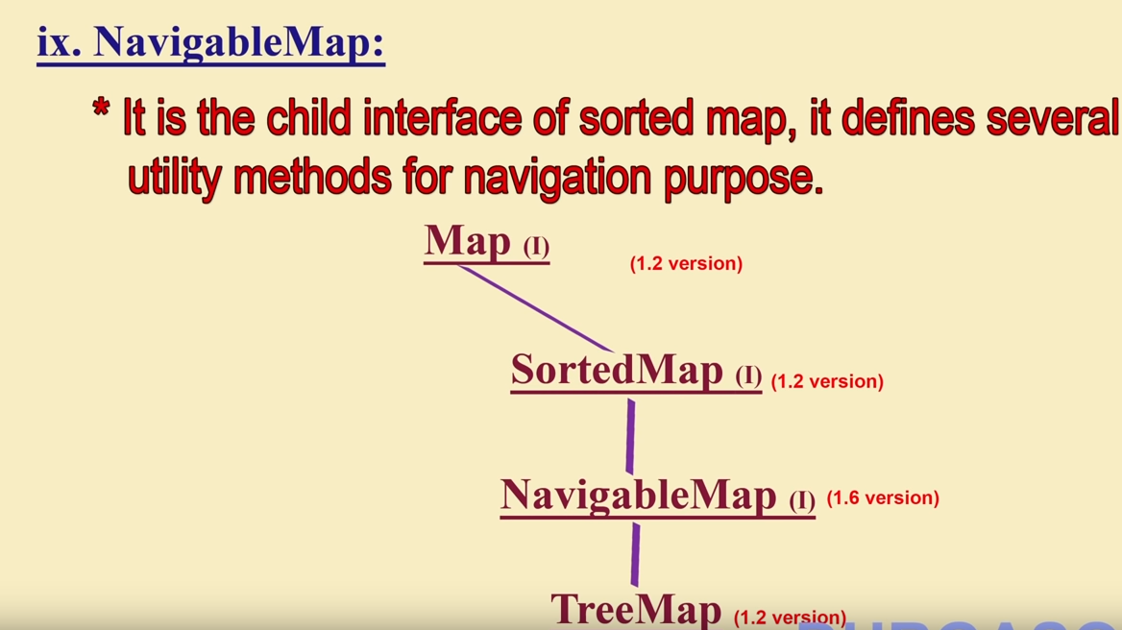

Collection is about the collection of individual objects. Whereas, Map is about the group of key-value pairs.

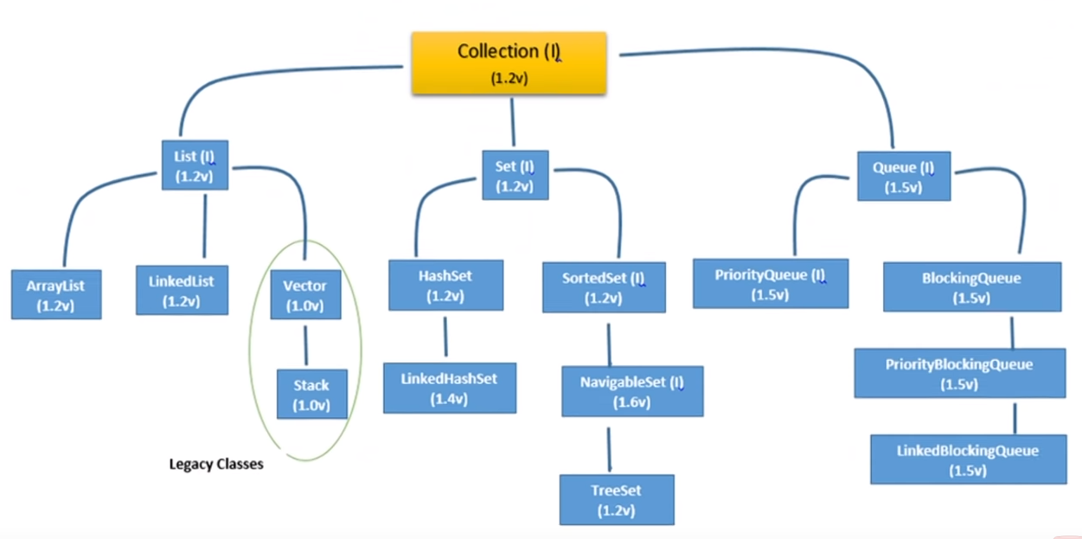

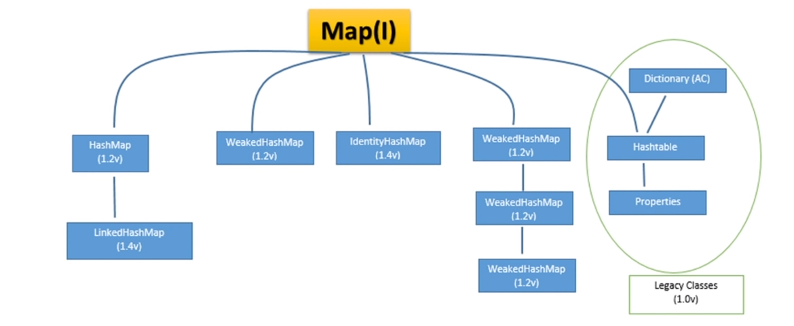

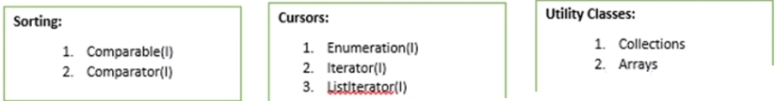

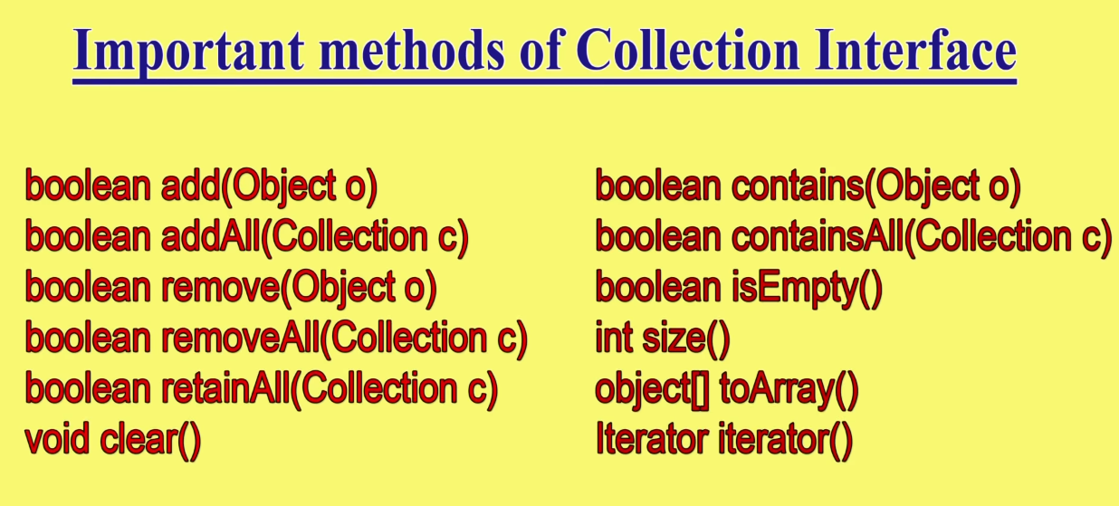

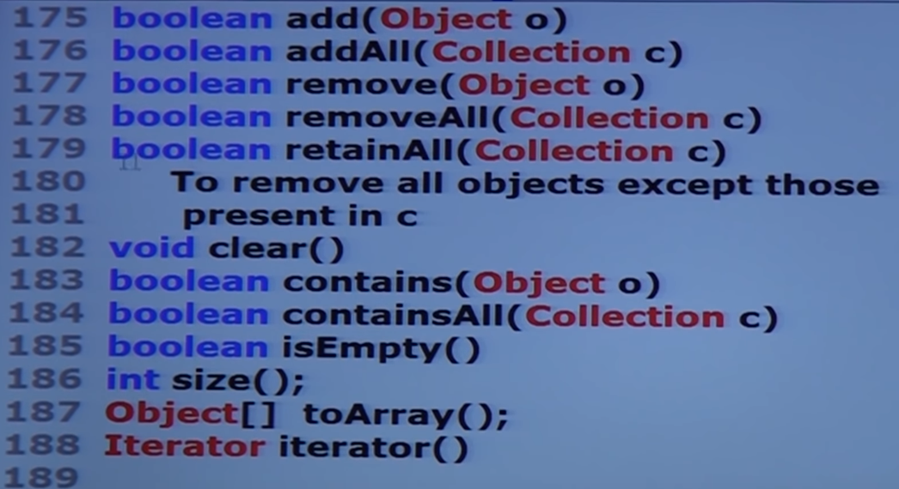

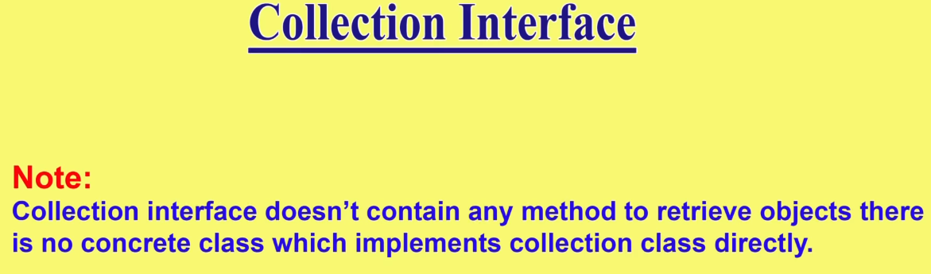

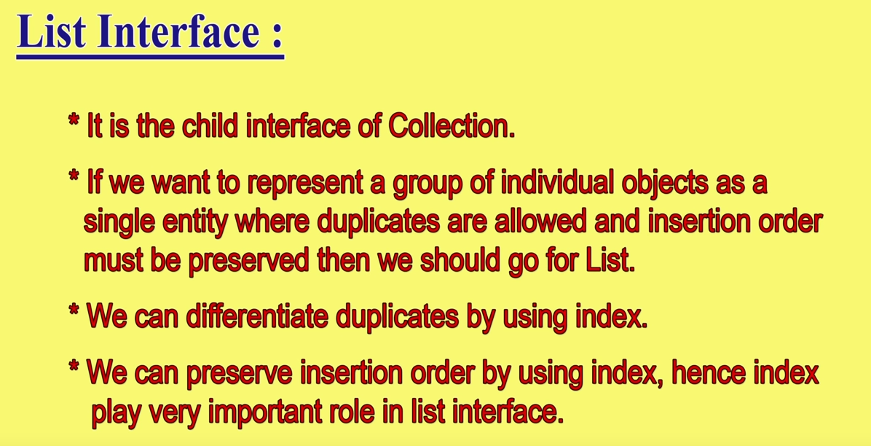

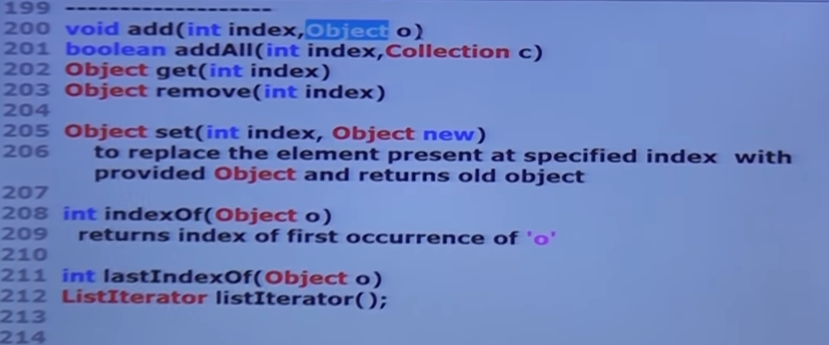

I added arraylist object i.e. a whole arraylist in a linkedlist then in the linked list the whole arraylist is stored at one location (i.e. entire arraylist occupies in one cell. Not a single cell allocated for every entry of the arraylist.) Check the bellow ex.

But, if I add A array list in B array list then all elements of arraylist A get separate cells in arraylist B.

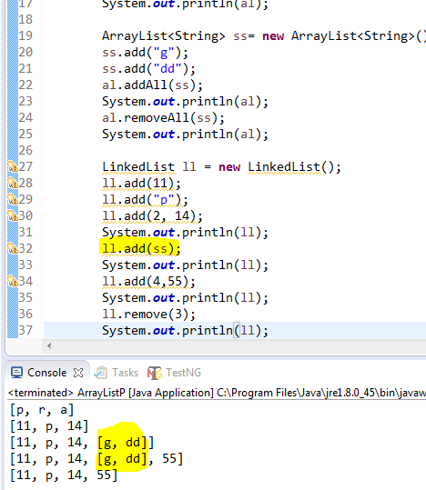

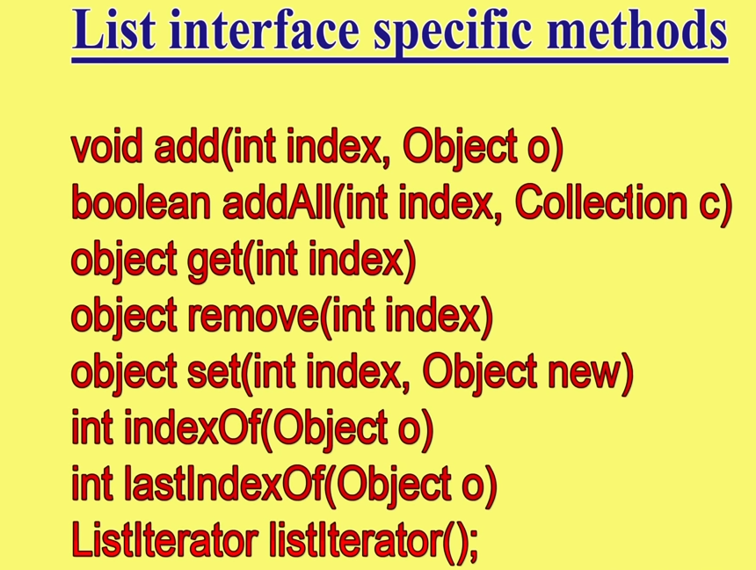

* Array list :

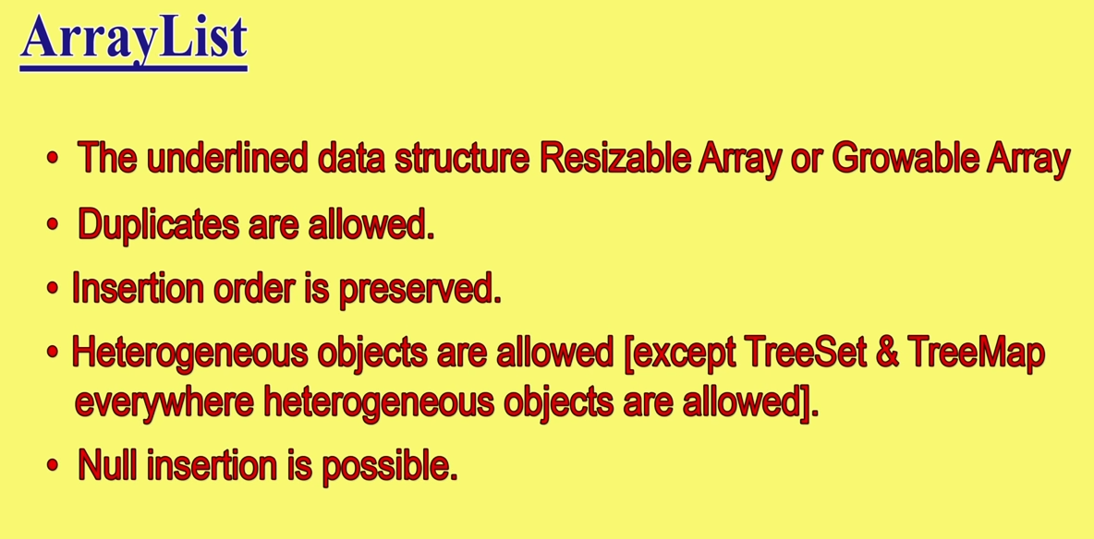

***Except Treeset&TreeMap everywhere heterogeneous obj. are allowed***

When we create array list for the first time default size is 10. When it’s full, and if we try to insert 11th element then a new bigger array list is created and all the 10 values copied to new array list and the older become eligible for garbage collection.

New array list will be created and the capacity of new arraylist will be calculated by below mentioned formula :

New array list’s capacity = (current capacity *3/2) + 1

For example : (10*3/2) + 1 = 16

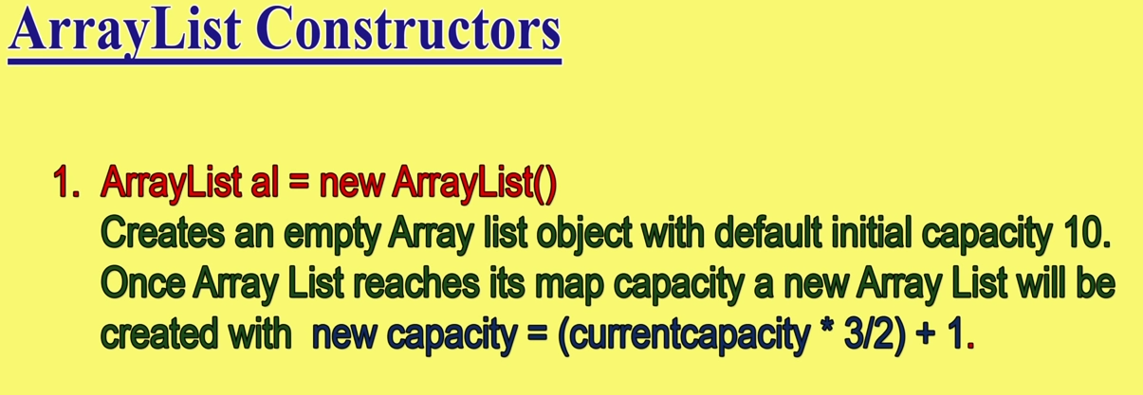

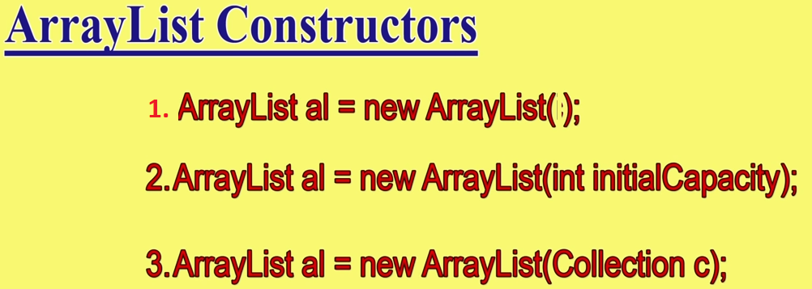

1 >Here we simply create array list without specifying its size. By default size will be taken as 10.

2 > Here we can pass the initial size as a parameter. If we pass 50, array list of size 50 will be created.

3 >Any collection object can be passed as a parameter here and that collection will be converted into an equivalent array list.

**VIMP :**

### Java Non-generic Vs. Generic Collection

Java collection framework was non-generic before JDK 1.5. Since 1.5, it is generic.

Java new generic collection allows you to have only one type of object in a collection. Now it is type safe so typecasting is not required at runtime.

Let's see the old non-generic example of creating java collection.

1. ArrayList al=**new** ArrayList();//creating old non-generic arraylist

Let's see the new generic example of creating java collection.

1. ArrayList<String> al=**new** ArrayList<String>();//creating new generic arraylist
2. ArrayList<String> al=**new** ArrayList<>();// It is also allowed to not mentions <String> at RHS

In a generic collection, we specify the type in angular braces. Now ArrayList is forced to have the only specified type of objects in it. If you try to add another type of object, it gives *compile time error*.

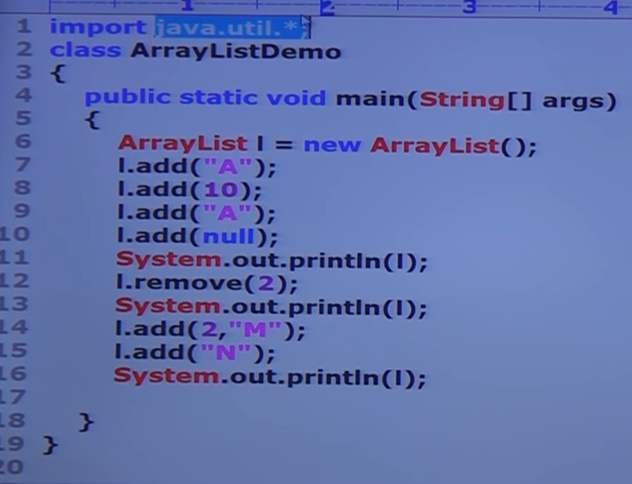

Output :

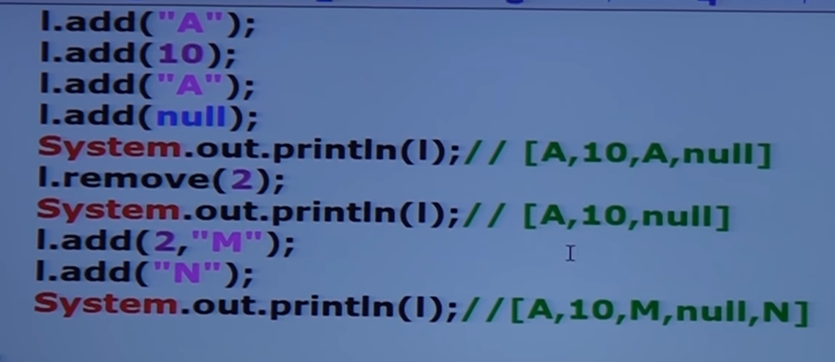

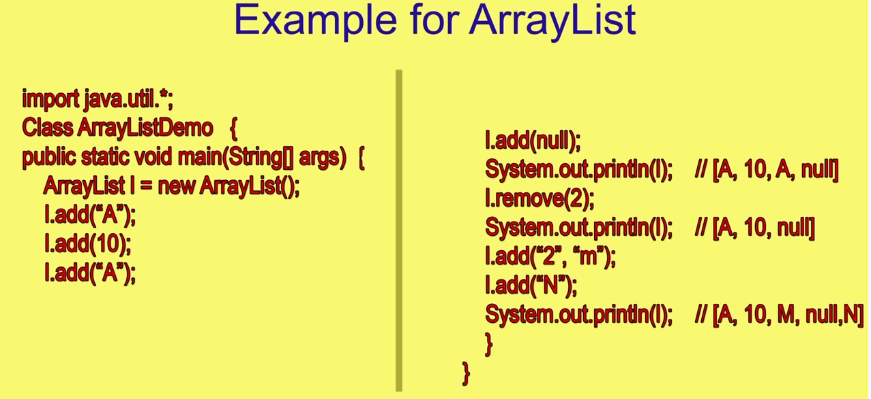

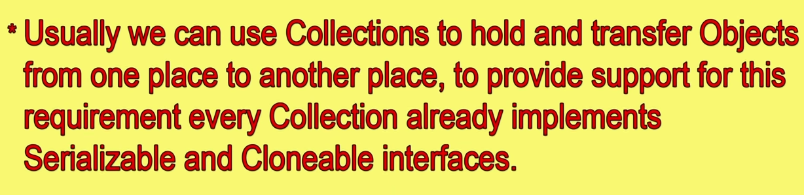

Serializable because it can be transferred via network, and after receiving it, a receiving end maintain the copy of it and then make changes on it. Therefore serializable and cloneable.

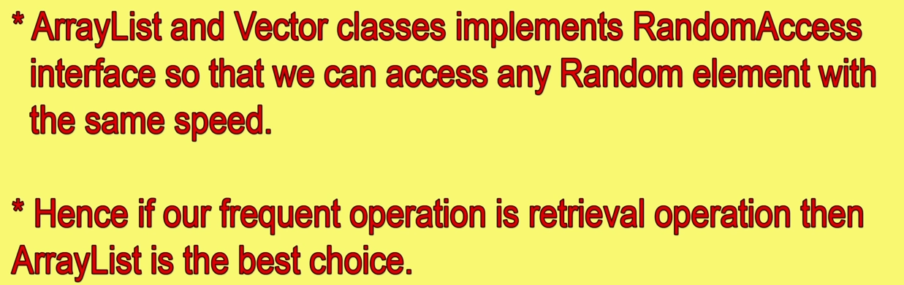

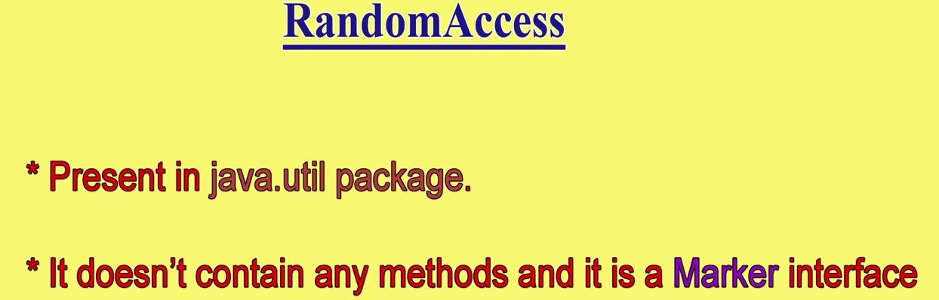

The purpose of ***RandomAccess*** Interface is to retrieve any random element in the Collection at the same speed. Example: I have a collection of 1 million objects. Implementing RandomAccess interface makes your time to retrieve the 10th element and 17869th element the **same**. This makes **ArrayList** and **Vector** more powerful.

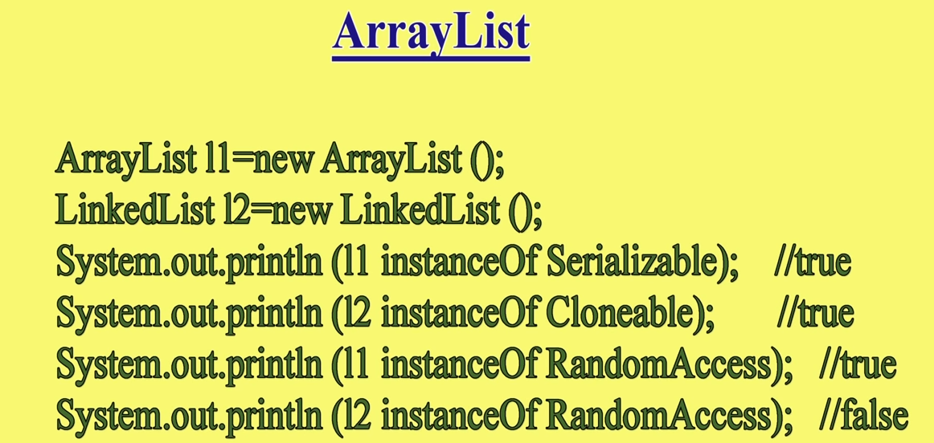

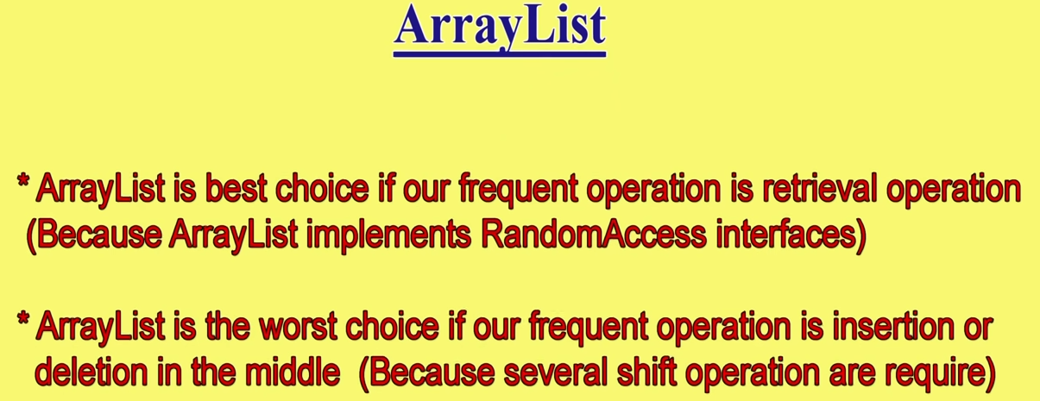

For example : array list contains 1 crore elements and I want to insert a new element at 5th place, then the entire list should be shifted by one place and it needs almost 1 crore shift operations. It is vey time consuming process. The same thing happens with delete operation between the list.

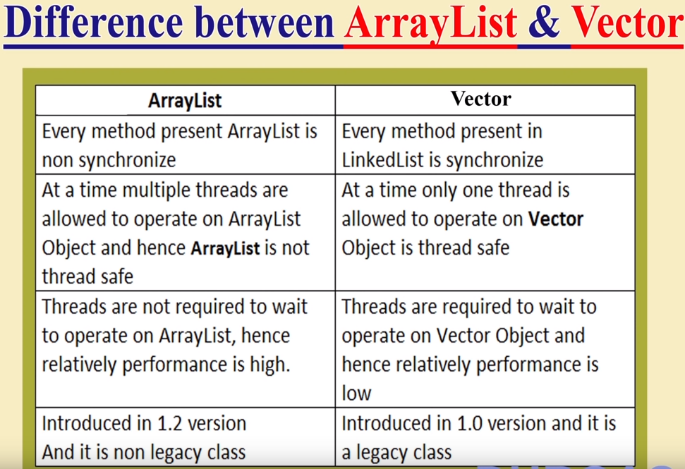

It implements **RandomAccess** interface It does **not** implement **RandomAccess** interface

Hence it is faster Hence it is slower.

* Linked list : Linked list is worst choice if frequent operation is retrieval. I.e. if a link list possess 1 crore elements, to access 10,00,000th element we have to start from 1st element, 1st element tells us the location/address of 2nd element, 2nd element tells us the address of 3rd element and so on. Its very time consuming to retrive elements from linked list, whereas insertion is very easy. If we want to add an element at 5000thlocation then we simply create a new node and change the pointer of 4999th and 5001st element and we easily insert it in between without any shift operation. Therefore, linked list is best if frequent operation is insertion and deletion

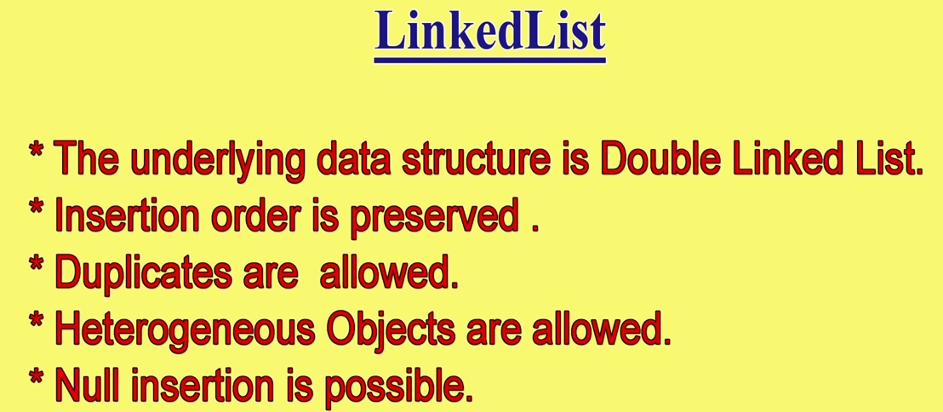

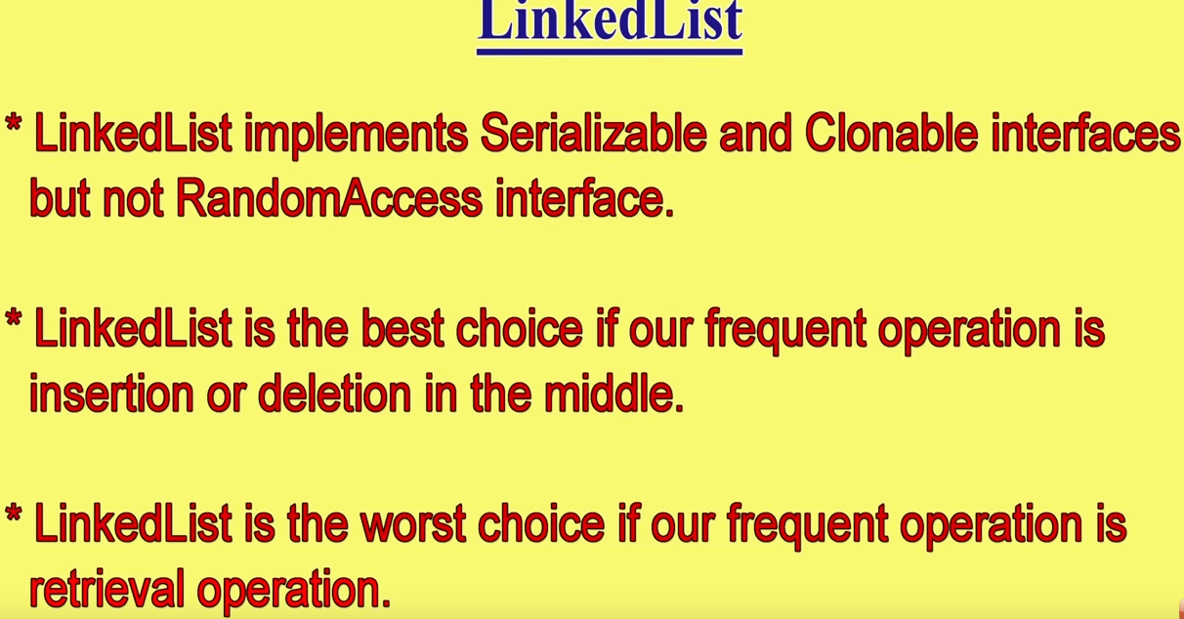

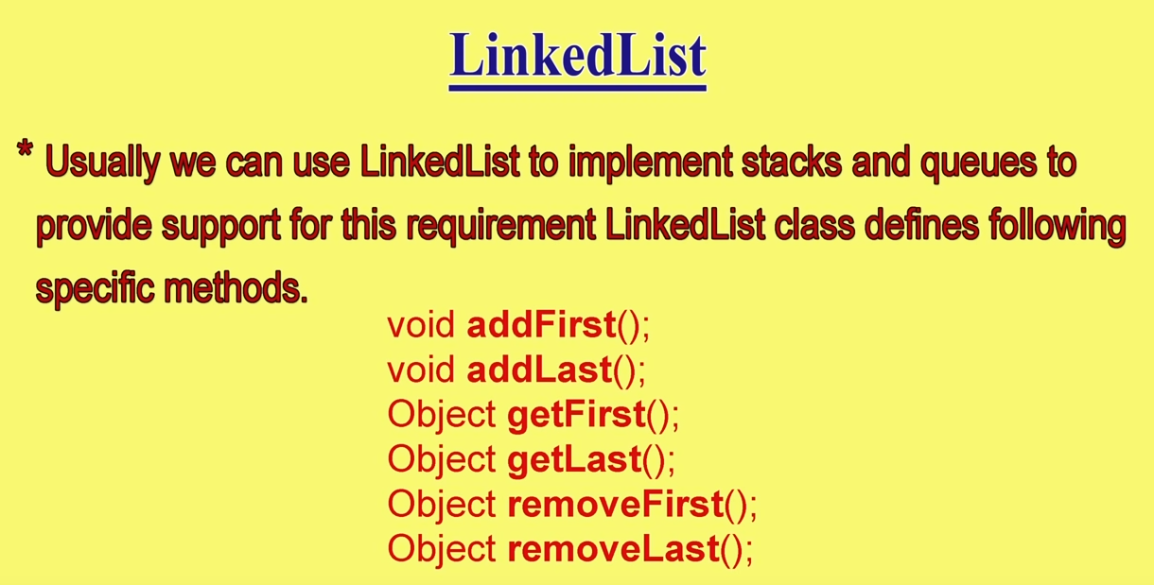

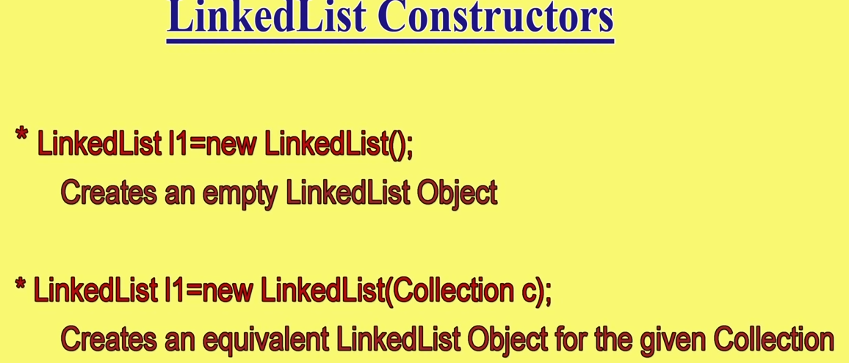

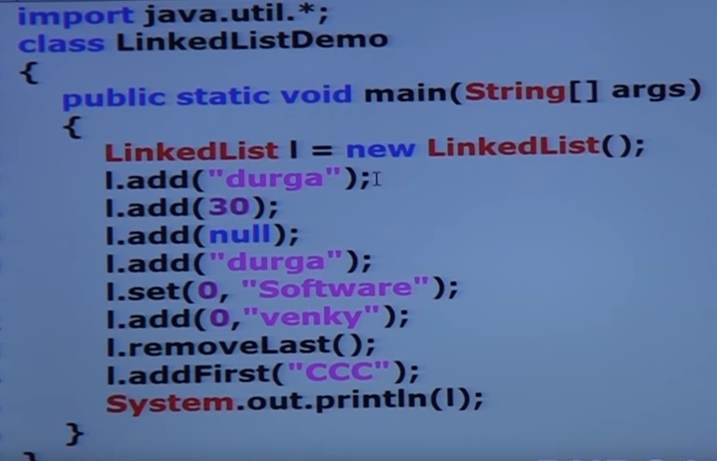

O/P :



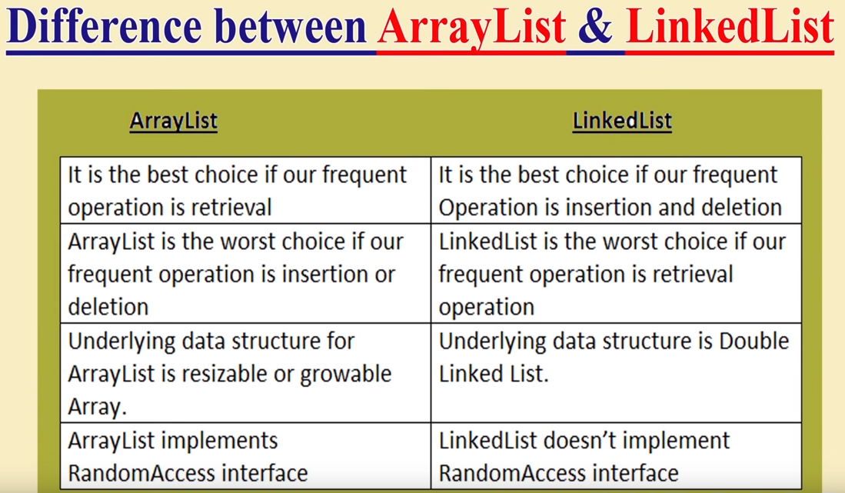

* Vector : Vector and Stack **both** are **synchronized**.

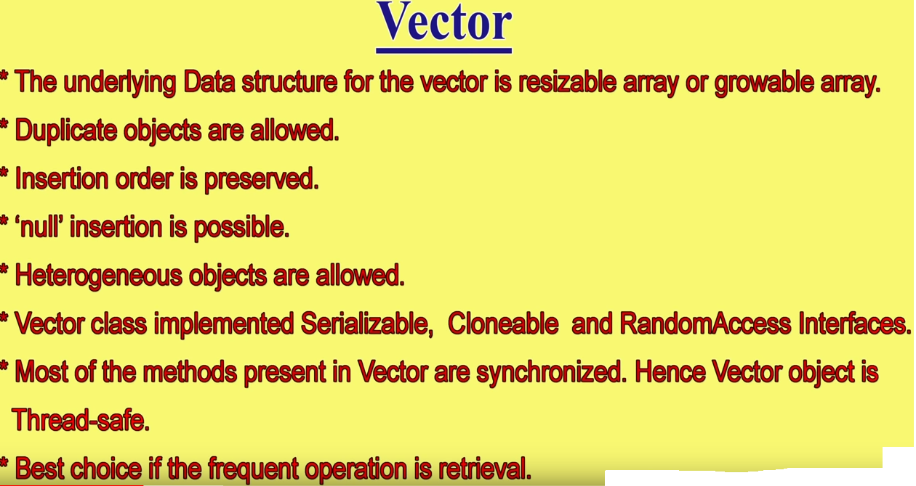

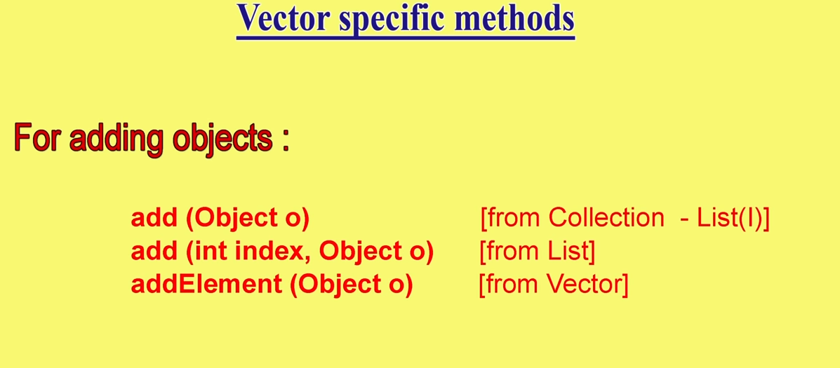

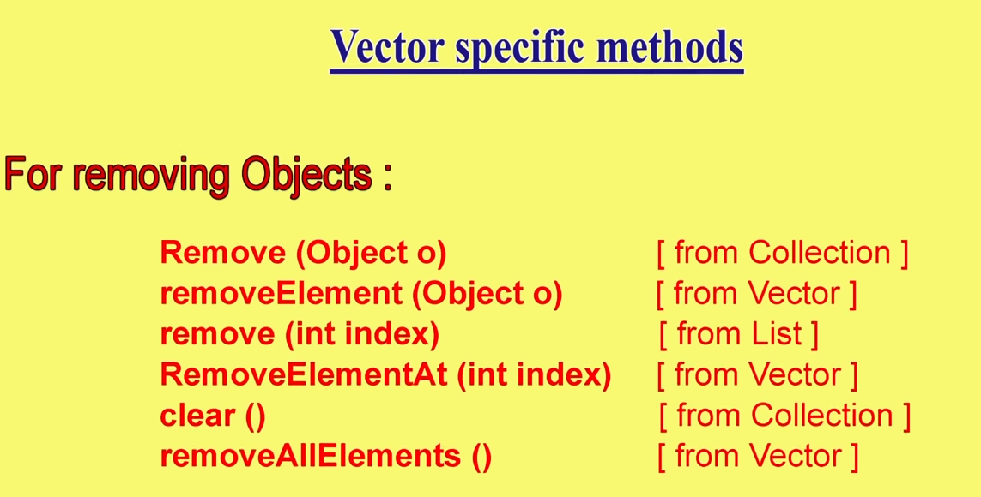

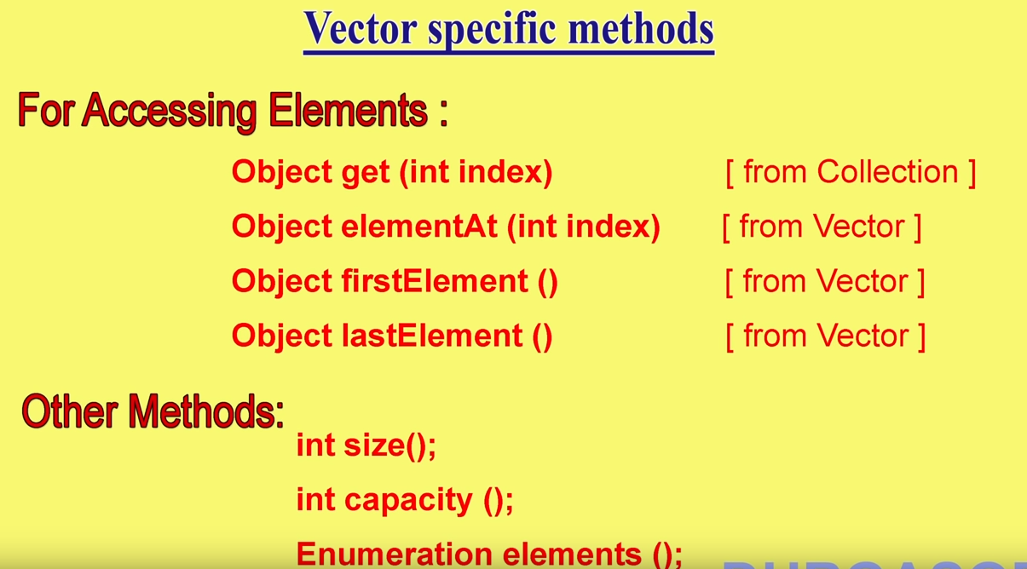

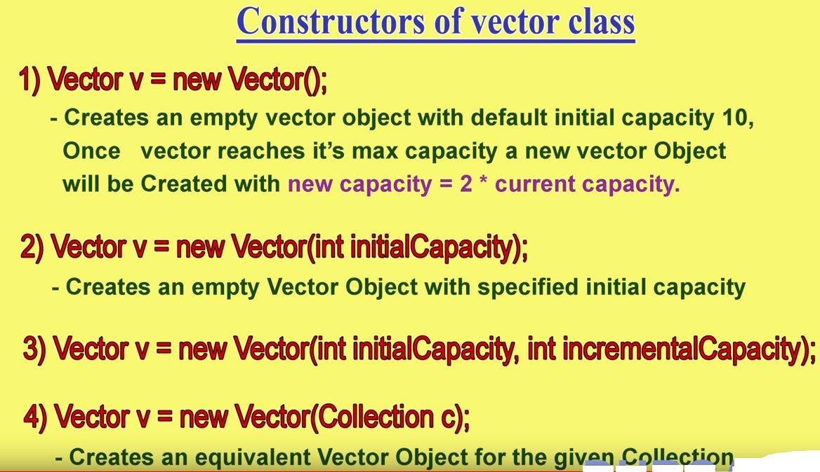

3 >If initial capacity is 100 and int incrementalCapacity is 5 then increments will be done by 5. I.e. once vector is full and we want to add 101stelement, a new vector of size 105 will be created. Once the new one is full, a vector with capacity 110 will be created.

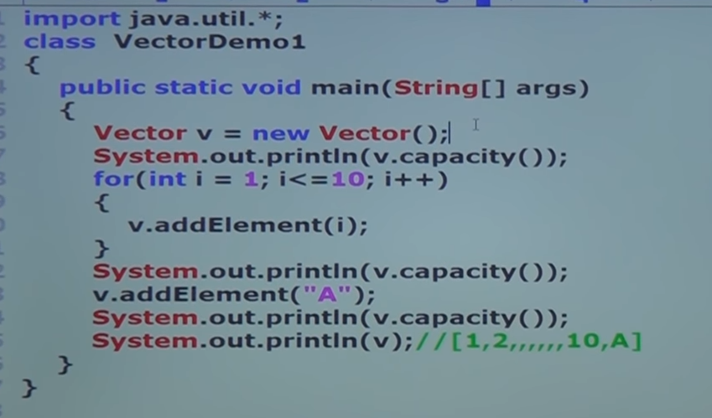

O/P :

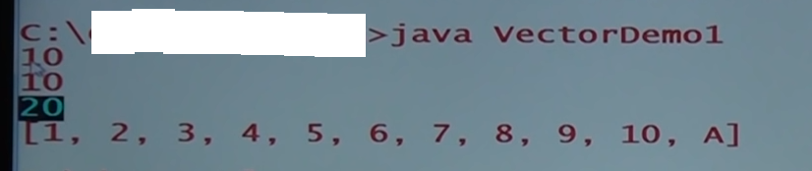

* Stack : Vector and Stack **both** are **synchronized**.

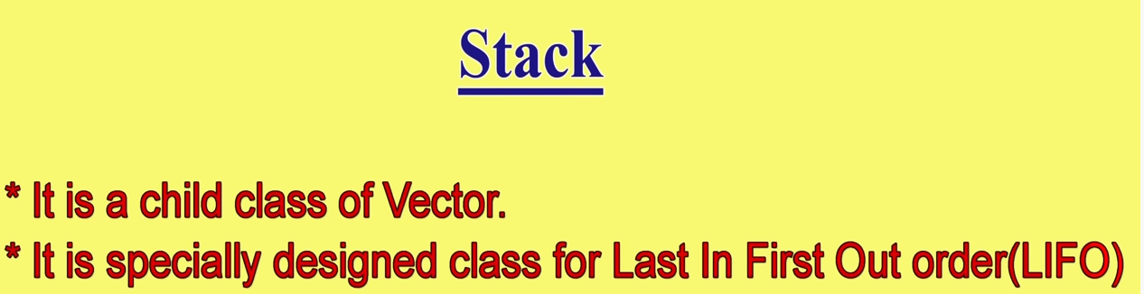

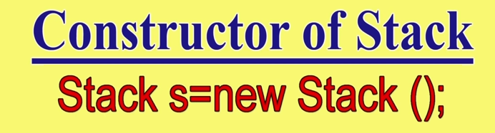

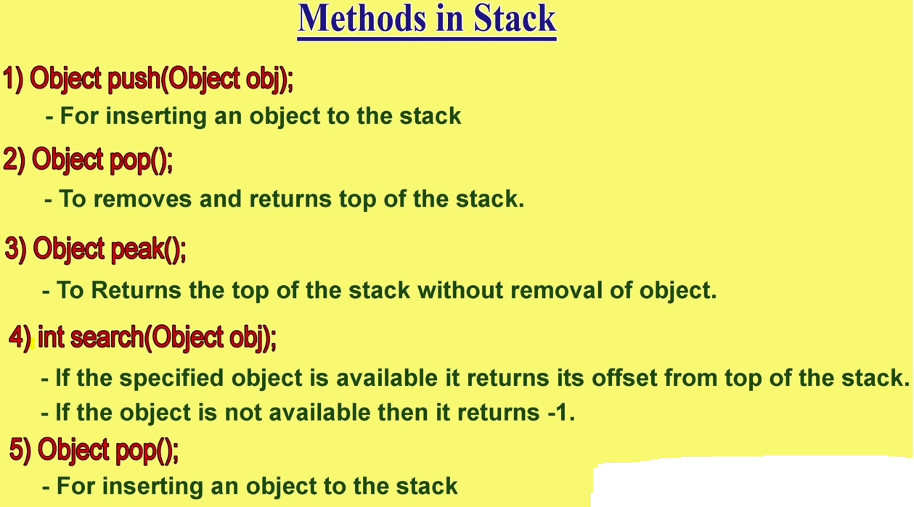

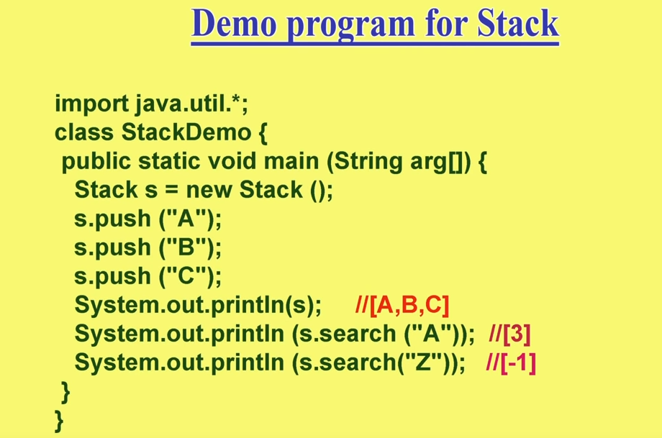

Difference between stack and vector :

* 1. stack is a stack. It can push and pop and it works in LIFO manner. **Moreover** we can use add, remove, remove specific object, add / remove in the middle.

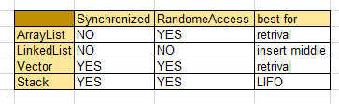

* HashSet :

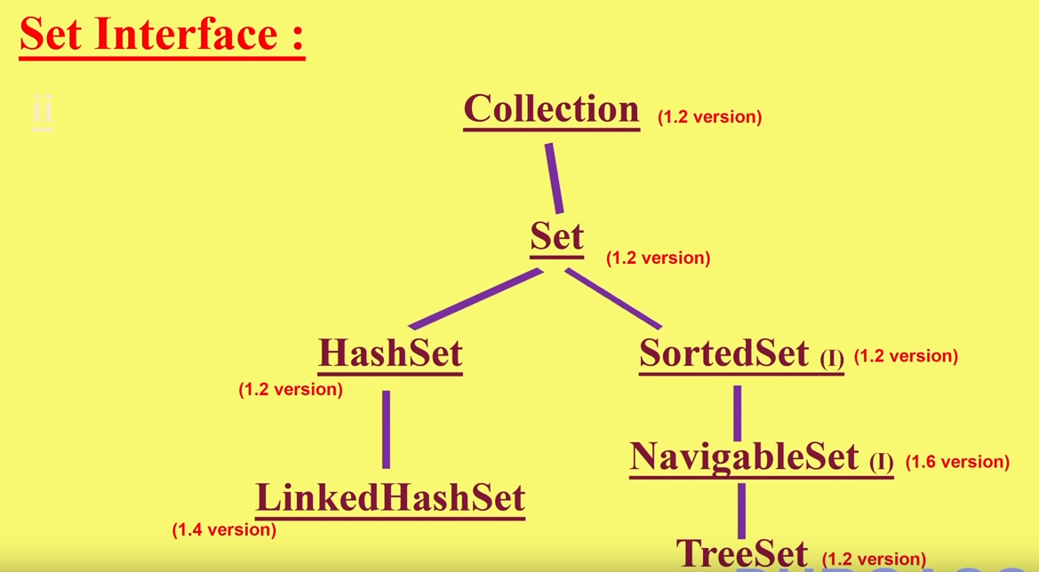

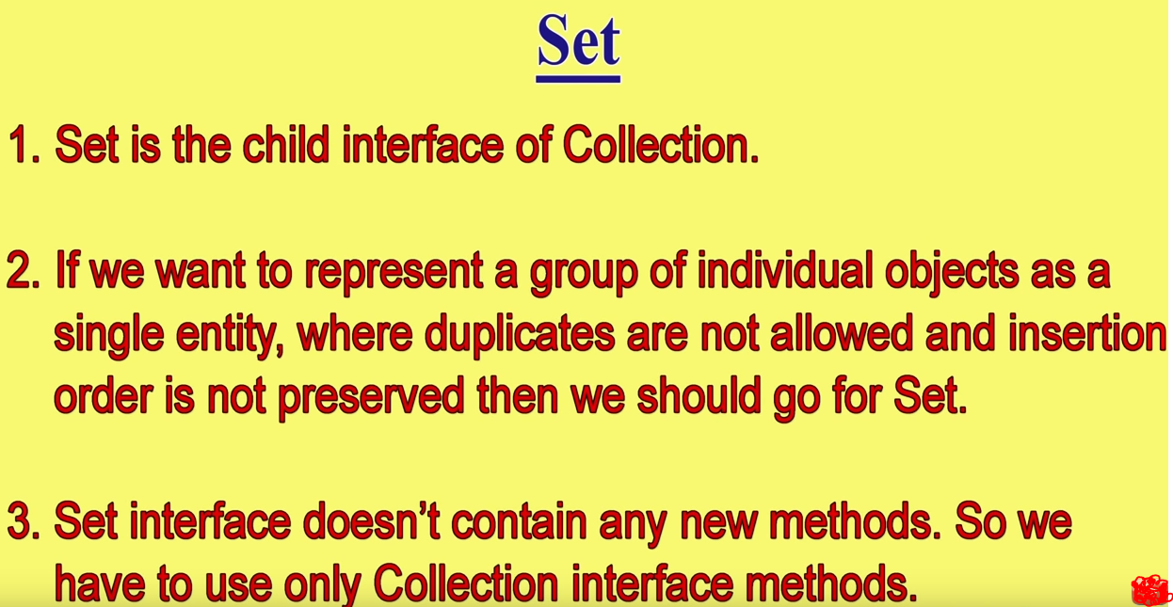

For frequent search operation HashSet is the best choice.

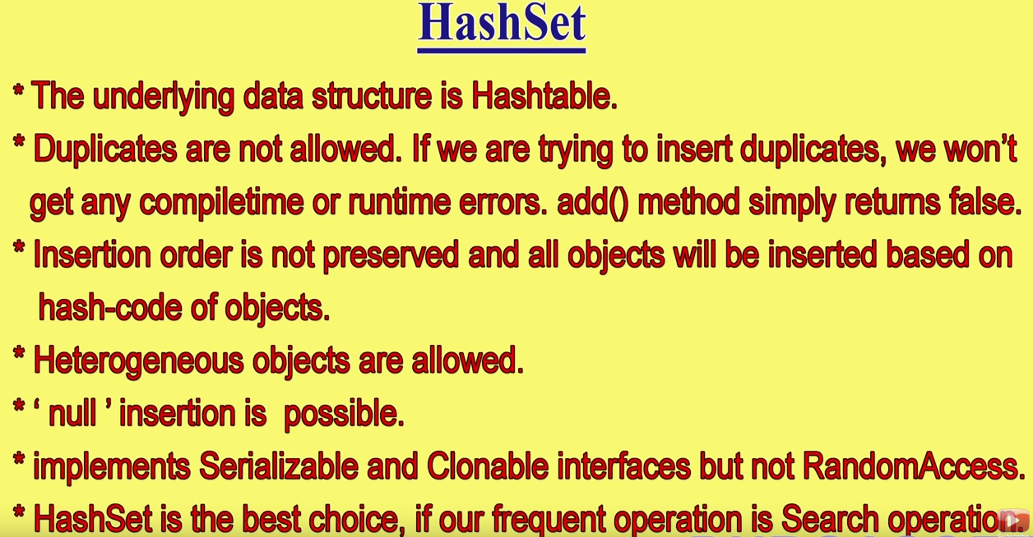

HashSet allows null values but, you can add only **one** null element to it. If you add multiple null values, but HashSet shows only one stored in it.

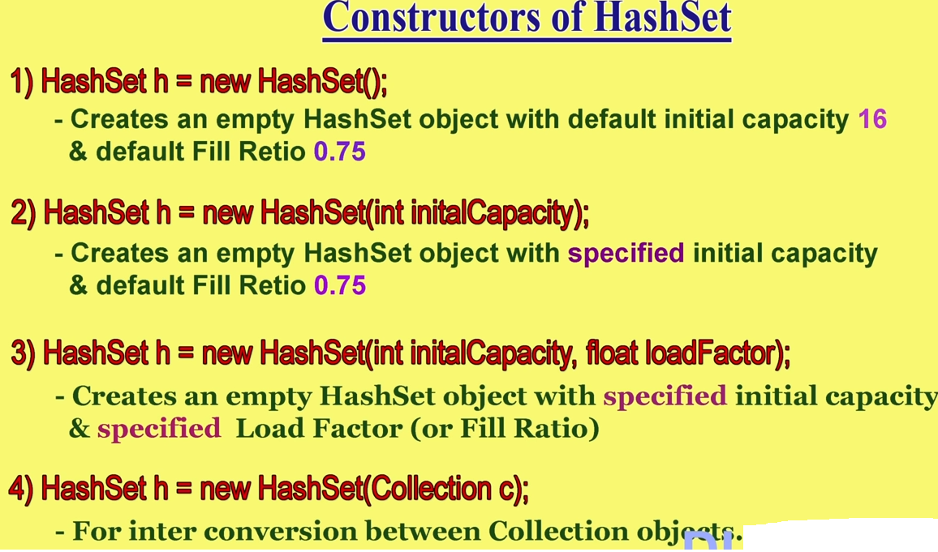

Fill ratio : 0.75 means a new bigger hash set will be created once the older HashSet is 75 ratio filled. It is also known as LoadFactor. HashSet store elements according to **Hash-Code**.

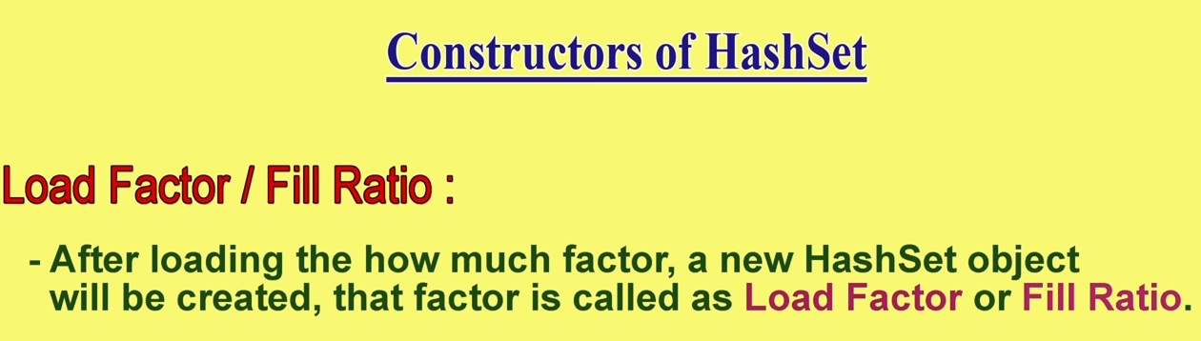

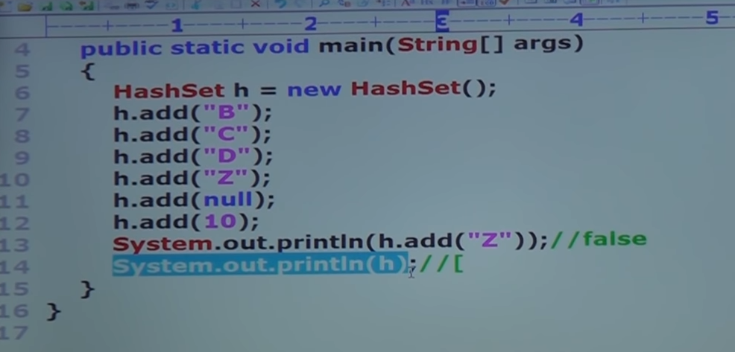

O/P :

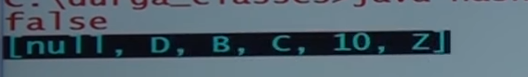

**Linked HashSet :** This class extends HashSet, but adds no members of its own.

LinkedHashSet maintains a linked list of the entries in the set, in **the order in which they were inserted**. This preserves insertion-order.

That is, when cycling through a LinkedHashSet using an iterator, the elements will be returned in the order in which they were inserted.

LinkedHashSet allows null values but, you can add **only one** null element to it. If you add multiple null values, but LinkedHashSet shows only one stored in it.

* 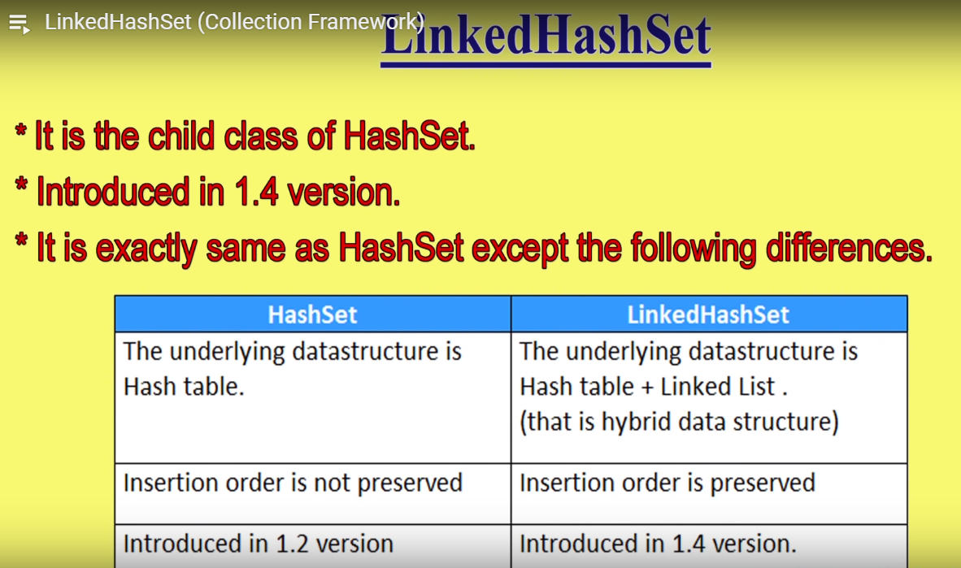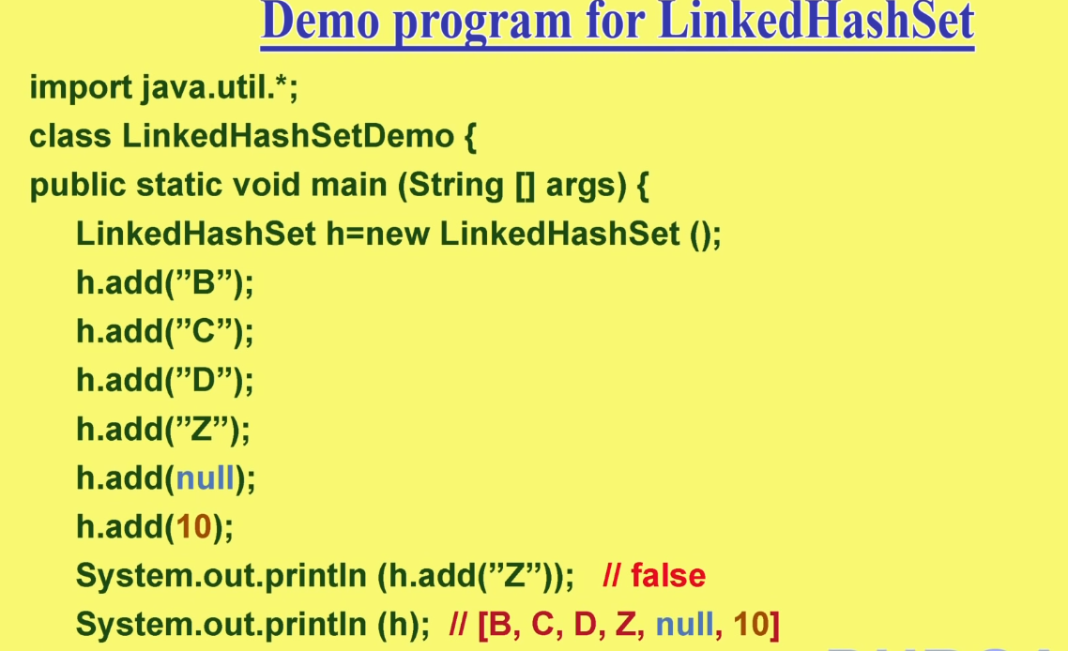Sorted set :

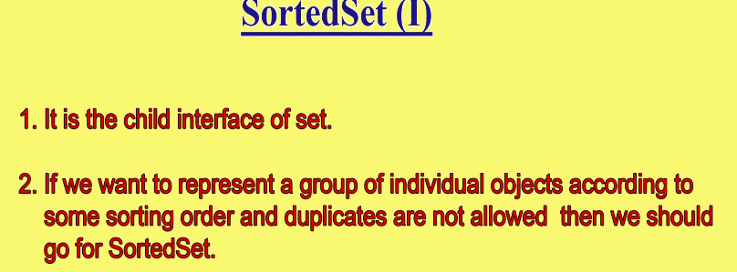

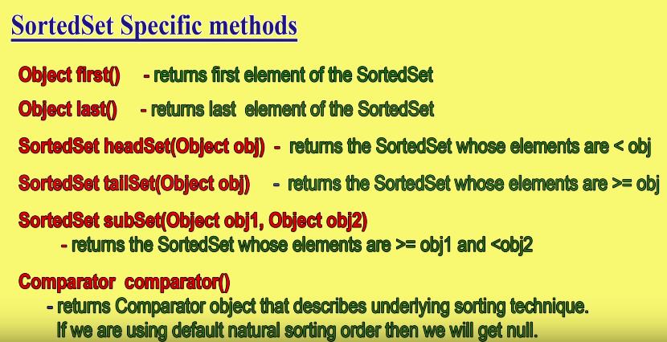

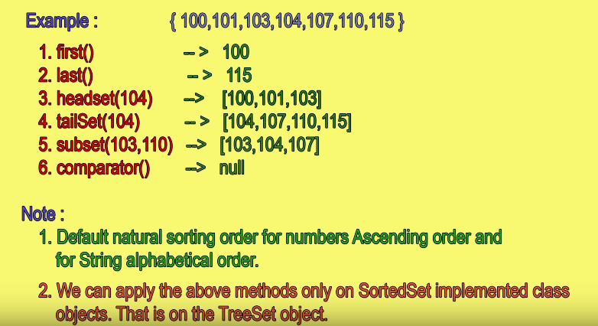

* Tree set :

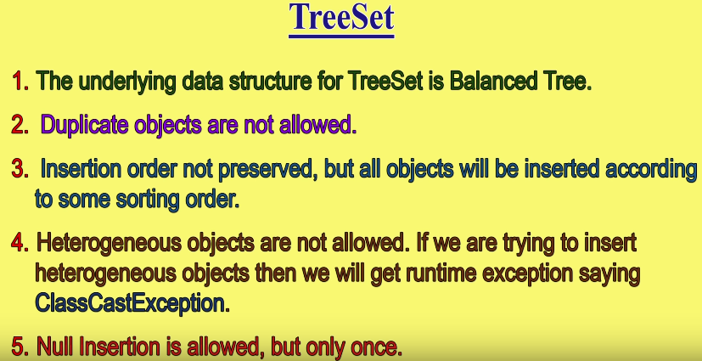Objects in TreeSet are sorted according to **Ascending** order

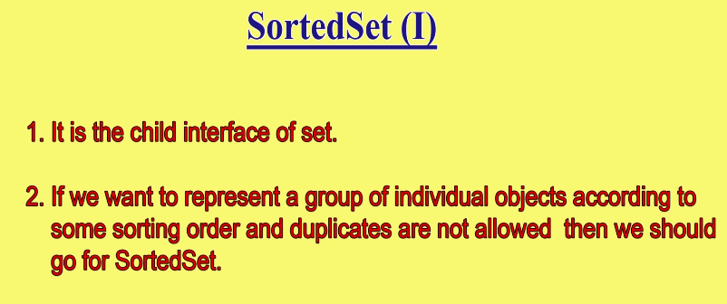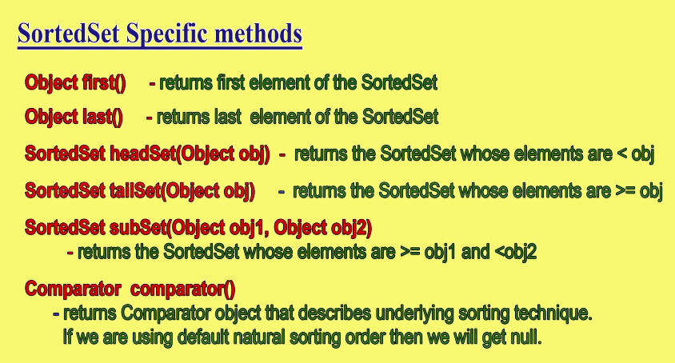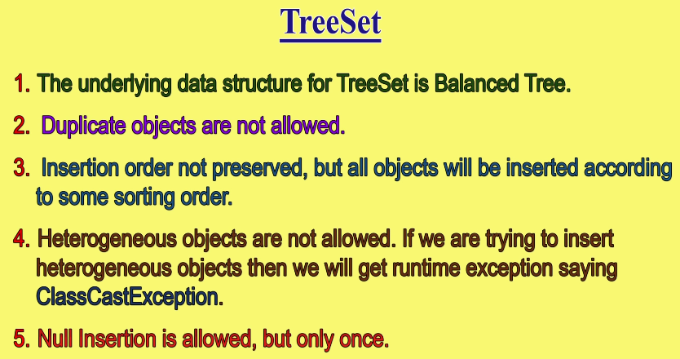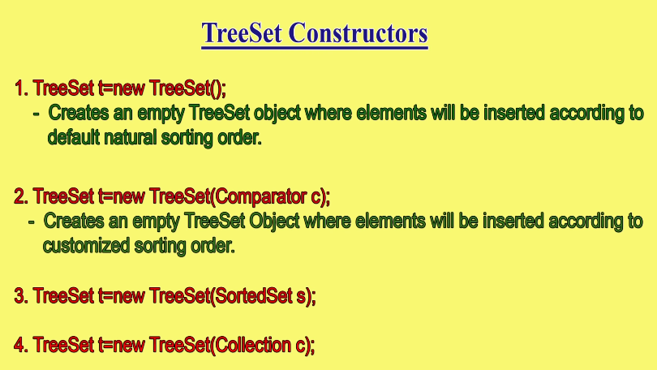

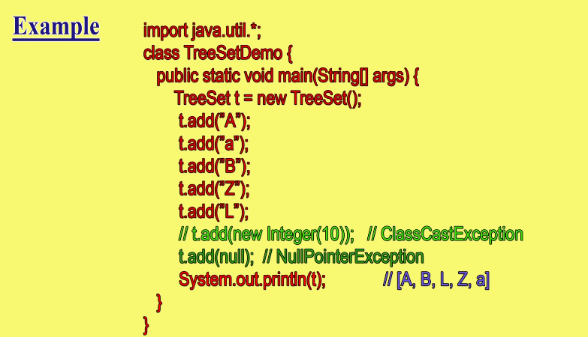

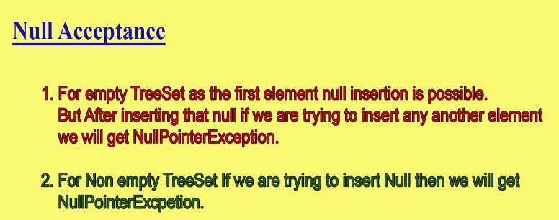

Difference between Treeset and Hashset and LinkedHashSet :

1. Duplicates not allowed in all 3.
2. Insertion order is same in the order it Is inserted in linked hash set, but in hash set insertion order is not preserved. Tree set :elements are arranged according to default natural sorting order
3. Heterogeneous allowed in hash set, and linked hash set, but heterogeneous **not** allowed in TreeSet.

**Queus** :

1. **PriorityQueue class** : **Java PriorityQueue** class is a queue data structure implementation in which objects are stored based on their **priority**. It places the inserted elements in que with a natural sorting order. *** It does not follows FIFO order.

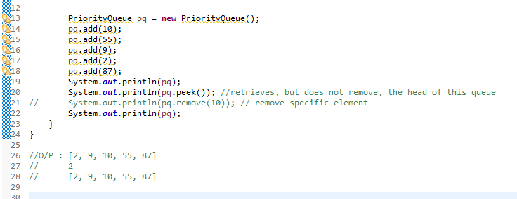

1. **BlockingQueue Interface** : It is an interface. A thread trying to enqueue an element in a full queue is blocked until some other thread makes space in the queue, either by dequeuing one or more element or clearing the queue completely. Similarly it blocks a thread trying to delete from an empty queue until some other treads inserts an item. BlockingQueue does not accept null value. If we try to enqueue null item, then it throws NullPointerException.

# PriorityBlockingQueue Class : Java PriorityBlockingQueue class is concurrent blocking queue data structure implementation in which objects are processed based on their priority. The “blocking” part of the name is added to imply the thread will block waiting until there’s an item available on the queue. In a priority blocking queue, added objects are ordered according to their priority. By default, the priority is determined by objects’ natural ordering. Default priority can be overridden by a Comparator provided at queue construction time.

# LinkedBlockingQueue class : LinkedBlockingQueue is an optionally-bounded blocking queue based on linked nodes. It means that the LinkedBlockingQueue can be bounded, if its capacity is given, else the LinkedBlockingQueue will be unbounded. The capacity can be given as a parameter to the constructor of LinkedBlockingQueue. This queue orders elements FIFO (first-in-first-out). It means that the head of this queue is the oldest element of the elements present in this queue. The tail of this queue is the newest element of the elements of this queue. The newly inserted elements are always inserted at the tail of the queue, and the queue retrieval operations obtain elements at the head of the queue.

**MAP :**Stores values in the form of key – value pair.

1. **HashMap :**

* Java HashMap class contains values based on the key.
* Java HashMap class contains only **unique** keys, but **duplicate** values are allowed
* Java HashMap class may have **one null key** and **multiple null values**.
* Java HashMap class is non synchronized.
* Java HashMap class **maintains no order**.
* The initial default capacity of Java HashMap class is 16 with a load factor of 0.75.

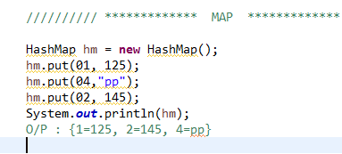

1. **LinkedHashMap** :

* A LinkedHashMap contains values based on the key. It implements the Map interface and extends the [HashMap](http://www.geeksforgeeks.org/java-util-hashmap-in-java/) class.
* It contains **only unique elements**.
* It may have **one null key and multiple null values**.
* It is non-synchronized.
* It is the same as HashMap with an additional feature that it **maintains insertion order.**

1. **WeakHashMap** : is an implementation of the Map interface. WeakHashMap is almost same as HashMap except in case of WeakHashMap, if object is specified as key doesn’t contain any references- it is eligible for garbage collection even though it is associated with WeakHashMap. i.e Garbage Collector dominates over WeakHashMap.
2. **IdentityHashMap :**

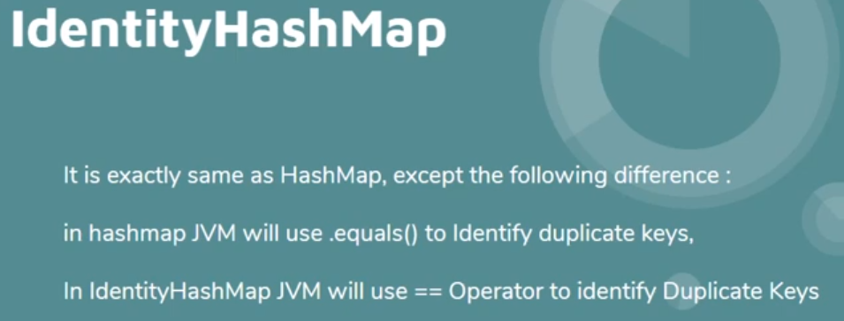

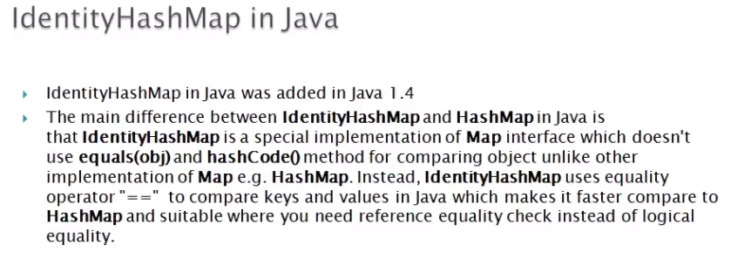

**Synchronization** : The process of allowing only one thread at a time to complete the task entirely for avoid inconsistency problem.

1. **Hash table :**

* Java Hashtable class contains only **unique** keys, but duplicate values are allowed, and it stores key and value pairs.
* Java Hashtable class **doesn't** allow null **key or value**.
* Java Hashtable class is synchronized.
* The initial default capacity of Hashtable class is 11 whereas loadFactor is 0.75.

**Hash table :** doesn’t preserve the insertion order, neither it sorts the inserted data based on keys or values. Which means no matter what keys & values you insert into Hashtable, the result would not be in any particular order. Duplicate values are allowed, but duplicate keys are not allowed.

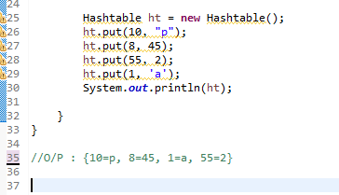

1. 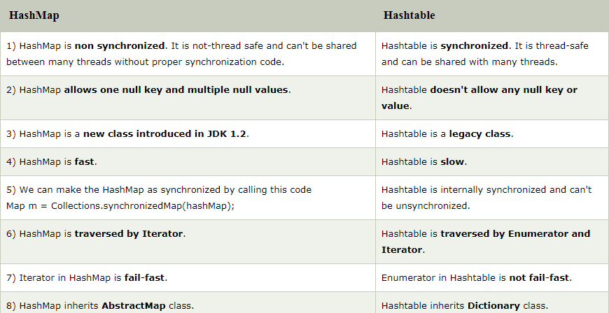HashMap is non synchronized means it can allow multiple threads to work. Whereas, HashTable is synchronized means it allows only one thread to work at a time.
2. **TreeMap :**

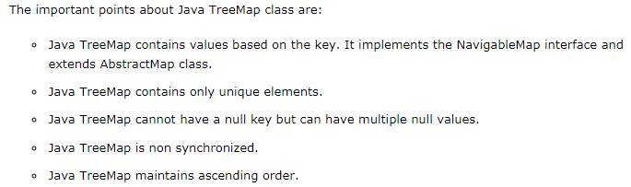TreeMap maintains **ascending** order of **KEYS,** Duplicate **keys** **not** allowed, but **duplicate** **values** are allowed

**Iterator for MAP : VIMP**

**public** **static** **void** main(String[] args) {

TreeMap<Integer, String> tm = **new** TreeMap<>();

tm.put(10, "pratik");

tm.put(5,"zz");

tm.put(12, "aa");

tm.put(1,"xyz");

System.***out***.println(tm);

**for**(Map.Entry<Integer, String> mpi : tm.entrySet())

{

System.***out***.println("Key: "+mpi.getKey()+" value: +mpi.getValue());

}

## **fail-fast Iterators in Java**

As name suggest fail-fast Iterators fail as soon as they realized that structure of Collection has been changed since iteration has begun. Structural changes means **adding, removing or updating** any element from collection while one thread is Iterating over that collection. fail-fast behavior is implemented by keeping a modification count and if iteration thread realizes the change in modification count it throws ConcurrentModificationException.

public class FailFastExample {

    public static void main(String[] args)

    {

        Map<String, String> cityCode = new HashMap<String, String>();

        cityCode.put("Delhi", "India");

        cityCode.put("Moscow", "Russia");

        cityCode.put("New York", "USA");

        Iterator iterator = cityCode.keySet().iterator();

        while (iterator.hasNext()) {

            System.out.println(cityCode.get(iterator.next()));

            // adding an element to Map

            // exception will be thrown on next call

            // of next() method.

            cityCode.put("Istanbul", "Turkey");

        }

    }

}

## **fail-safe Iterator in java**

Contrary to fail-fast Iterator, fail-safe iterator doesn't throw any Exception if Collection is modified structurally. While one thread is Iterating over it because they **work on clone of Collection** instead of original collection and that’s why they are called as fail-safe iterator. Iterator of CopyOnWriteArrayList is an example of fail-safe Iterator also iterator written by ConcurrentHashMap keySet is also fail-safe iterator and never throw ConcurrentModificationException in Java.

class FailSafe {

    public static void main(String args[])

    {

        CopyOnWriteArrayList<Integer> list

            = new CopyOnWriteArrayList<Integer>(new Integer[] { 1, 3, 5, 8 });

        Iterator itr = list.iterator();

        while (itr.hasNext()) {

            Integer no = (Integer)itr.next();

            System.out.println(no);

            if (no == 8)

                // This will not print,

                // hence it has created separate copy

                list.add(14);

        }

    }

}

Iterator in Java

* ‘Iterator’ is an **interface** which belongs to collection framework. It allows us to traverse the collection, access the data element and remove the data elements of the collection. It is **applicable for all Collection classes**. So it is also known as Universal Java Cursor. It supports both READ and REMOVE Operations. java.util package has public interface Iterator and contains **three methods**:

1. **Boolean.hasNext():** It returns true if Iterator has more element to iterate.
2. **Object.next():** It returns the next element in the collection until the hasNext()method return true. This method throws ‘NoSuchElementException’ if there is no next element.
3. **void remove():** It removes the current element in the collection. This method throws ‘IllegalStateException’ if this function is called before next( ) is invoked.

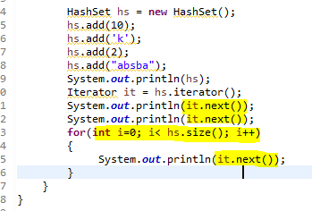

Read more: <https://javarevisited.blogspot.com/2012/02/fail-safe-vs-fail-fast-iterator-in-java.html#ixzz6FDxNQNIU>

TO START : default sorting order of all maps, write prog of all collections, end this topic today

<https://www.youtube.com/watch?v=fGOMCxitc0g&list=PLd3UqWTnYXOkVR3OR9UZGyEt9RFUbaTMZ&index=32>

IMP interview question :

1. Difference between list and set
2. What is random access? Tell something about it.
3. What is the difference between array list and vector
4. What will happen if I try to insert duplicate in HashSet?

**Generics :**

Java collection store only objects. No PRIMITIVE data elements with PRIMITIVE data types (int, char, string etc.) will be directly stored in collecton. So, every element stored in Collections should be **OBJECT ONLY.**

Collections can store heterogeneous objects. But while retrieving the elements we need to typecast the objects to primitive type. For example if collection has 3 int values and 2 char values. We need to take care to type cast appropriate element according to its type. Ex. :

ArrayList all = **new** ArrayList();

all.add(10);

all.add(1, 11);

all.add(20);

all.add('B'); // heteroginius objects are allowed

**int** h = (**int**) all.get(0);// typecast Integer object to int

System.***out***.println(h);

**char** ch = (**char**) all.get(3); // typecast Character object to char

System.***out***.println(ch);

// O/P : 10 B

Here we type casted Integer object to int and Character object to char. Whithout type casting we cannot convert object value to primitive type. Moreover, it is overhead to remember the type of the object and then typecast it to appropriate primitive type. To solve this problem OR to achieve Type Safety, **Generics is introduced in Java**. It was introduced in Java **1.5** Ex:

ArrayList<String> ppr = **new** ArrayList<String>(); //<String> : is Generics

ppr.add("ok");

ppr.add("hi");

ppr.add("hello");

ppr.add(3,"p");

String gs = ppr.get(1);// NO type casting required if we use generics

String gs2 = ppr.get(2); );// NO type casting required if we use generics

System.***out***.println(gs2);

//O/P : hi hello

Java **1.7** onwards, No need to mention <String>on the right hand side. I.e. we can only write :

ArrayList<String> ppr = **new** ArrayList<>();//<String> : not needed on RHS

*** In **Generics** we let the machine know that this collection will hold only specific type of **objects** and we mention that in the <> brackets. In the above example, collection will store **only String Objects**. Before generics, we can store any type of objects in the collection, i.e., non-generic. Now generics force the java programmer to store a specific type of objects.

All collection classes of java store memory location of the objects they collect. The primitive values do not *fit in* to this criteria.  
To avoid this problem, JDK 5 and onwards have **autoboxing** - wherein the primitives are **converted to appropriate objects** and back when they are added or read from the collections.

If you look at the ArrayList source code, it uses Object array to store the values. This is one of the reason autoboxing happens when you try to store the primitive types in collections.

Boxing, auto-boxing, and Un-boxing in Java :

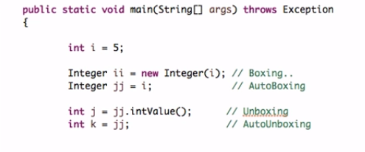

|  |  |  |
| --- | --- | --- |
| Interface | Class Name | Synchronized |
| List | ArrayList | NO |
|  | LinkedList | NO |
|  | Vector | YES |
|  | Stack | YES |
| Set | HashSet | NO |
|  | LinkedHashSet | NO |
|  | TreeSet | NO |
| Queue | PriorityQueue | NO |
|  | BlockingQueus | YES |
|  | PriorityBlockingQueue | YES |
|  | LinkedBlockingQueue | NO |
| Map | HashMap | NO |
|  | LinkedHashMap | NO |
|  | IdentityHashMap | NO |
|  | WeakHashMap | NO |
|  | HashTable | YES |
|  | TreeMap | NO |

